|  |
| --- |
| Bergen County Technical School |
| AP Physics B Summer Assignment |
| 2011 |
|  |
|  |

|  |
| --- |
| Solve all problems on separate paper. This will be due the first week of school. If you need any help you can e-mail Mr. Zavorotniy at yurzav@bergen.org, Mr. Rice at gleric@bergen.org or Ms. DiBiano at mardib@bergen.org. |

**Kinematics**

1. An object is traveling at a constant velocity of 11 m/s when it experiences a constant acceleration of 1.5 m/s2 for a time of 14 s. What will its velocity be after that acceleration?
2. An object is thrown vertically up with a velocity of 35 m/s. What was the maximum height it reached?
3. A boy throws a ball vertically up and catches it after 3 s. What height did the ball reach?
4. An object is moving at a velocity of 5.8 m/s. It accelerates to a velocity of 25 m/s over a time of 3.3 s. What acceleration did it experience?
5. A car which is traveling at a velocity of 9.6 m/s undergoes an acceleration of 4.2 m/s2 over a distance of 450 m. How fast is it going after that acceleration?
6. A marble is projected vertically up by a spring gun, and reaches the maximum height of 9.8 m. What is the initial speed of the marble? How long was the marble in the air?
7. An arrow is shot vertically up by a bow, and after 8 s returns to the ground level. What is the initial velocity of the arrow? How high did it go?
8. Starting at the position, x0 = 10 m, you travel at a velocity of 4 m/s for 2 s.
   1. Determine your position at the times of 0s; 0.5s; 1s; and 1.5s.
   2. Draw the Position versus Time for your travel during this time.
   3. Draw the Velocity versus Time graph for your trip.
9. The velocity versus time graph, right, describes the motion of three different cars moving along the x-axis.
   1. Describe, in words, the velocity of each of the cars. Make sure you discuss each car’s speed and direction.
   2. Calculate the displacement of each car during its 6 s trip.
   3. Calculate the distance traveled by each car during its 6 s trip.

**Dynamics**

1. 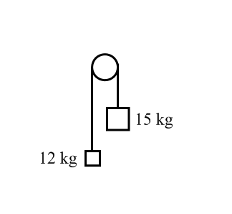A 12 kg load hangs from one end of a rope that passes over a small frictionless pulley. A 15 kg counterweight is suspended from the other end of the rope. The system is released from rest.
   1. Draw a free-body diagram for each object showing all applied forces in relative scale. Next to each diagram show the direction of the acceleration of that object.
   2. Find the acceleration each mass.
   3. What is the tension force in the rope?
   4. What distance does the 12 kg load move in the first 3 s?
   5. What is the velocity of 15 kg mass at the end of 5 s?

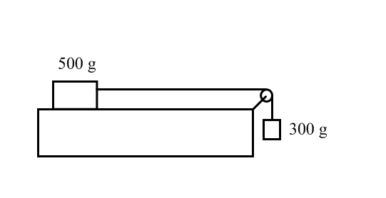

1. A 500 g block lies on a horizontal tabletop. The coefficient of kinetic friction between the block and the surface is 0.25. The block is connected by a massless string to the second block with a mass of 300 g. The string passes over a light frictionless pulley as shown above. The system is released from rest.
   1. Draw clearly labeled free-body diagrams for each of the 500 g and the 300g masses. Include all forces and draw them to relative scale. Draw the expected direction of acceleration next to each free-body diagram.
   2. Use Newton’s Second Law to write an equation for the 500 g mass.
   3. Use Newton’s Second Law to write an equation for the 300 g mass.
   4. Find the acceleration of the system by simultaneously solving the system of two equations.
   5. What is the tension force in the string?
2. 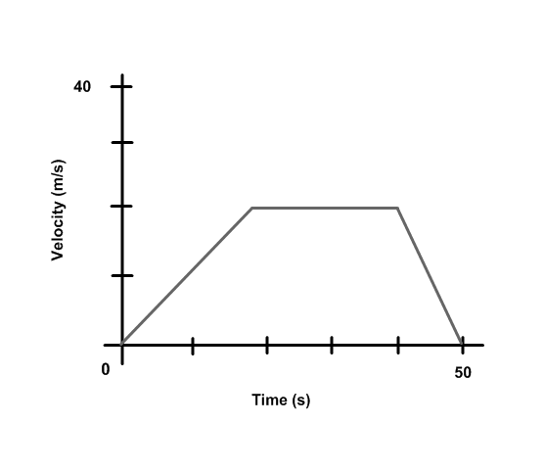A 2000 kg car travels in a straight line on a horizontal road. The relationship between car’s velocity and the time are given by the above graph.
   1. What is the car’s acceleration during first 20 s?
   2. What is the net force applied by the engine during the first 20 s?
   3. What is the car’s acceleration from 20 s to 40 s?
   4. What is the net force applied by the engine during this time?
   5. What is the car’s acceleration from 40 s to 50 s?
   6. What is the net force applied by an engine during this time?

**Uniform Circular Motion**

1. A 0.65 kg ball is attached to the end of a string. It is swung in a vertical circle of radius 0.50 m. At the top of the circle its velocity is 2.8 m/s.
   1. Draw a free body diagram for the ball when it is at the top of the circle. Next to that diagram indicate the direction of its acceleration.
   2. Use that free body diagram to set up the equations needed to determine the Tension in the string.
   3. Solve those equations for the Tension in the string.
2. A 0.65 kg ball is attached to the end of a string. It is swung in a vertical circle of radius 0.50 m. At the bottom of the circle its velocity is 2.8 m/s.
   1. Draw a free body diagram for the ball when it is at the bottom of the circle. Next to that diagram indicate the direction of its acceleration.
   2. Use that free body diagram to set up the equations needed to determine the Tension in the string.
   3. Solve those equations for the Tension in the string.

**Universal Law of Gravitation**

1. As shown in the diagram below, a 1000 kg asteroid is located 6.8x106 m from the center of the Mars. The mass of the Mars is 6.4x1023 kg.

Mars

Asteroid

1. Determine the force of gravity acting on the asteroid, due to the Mars. Calculate the magnitude and state the direction.
2. Compare your answer in a) to the force of gravity acting on the Mars, due to the asteroid. Indicate that force on the diagram above.
3. On the diagram above, indicate the direction the asteroid would accelerate if released. Label that vector “a”.
4. Calculate the acceleration the asteroid would experience.
5. If instead of falling, the asteroid were in a stable orbit, indicate on the diagram above a possible direction of its velocity. Label that vector “v”.
6. Calculate the velocity the asteroid needs to be in a stable orbit.
7. Calculate the period of the asteroid orbiting the earth.

**Work and Energy**

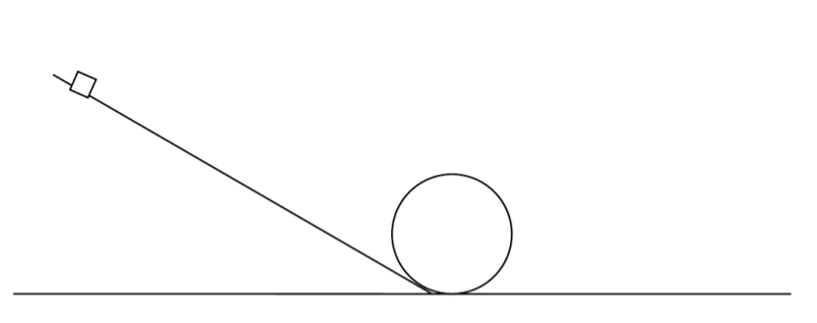

1. A small block, with a mass of 250 g, starts from rest at the top of the apparatus shown above. It then slides without friction down the incline, around the loop and then onto the final level section on the right. The maximum height of the incline is 80 cm, and the radius of the loop is 15 cm.
   1. Find the initial potential energy of the block
   2. Find the velocity the block at the bottom of the loop
   3. Find the velocity of the block at the top of the loop.
   4. What is the normal force on the block at the lowest point of the loop?
   5. What is the normal force on the block at the highest point of the loop?

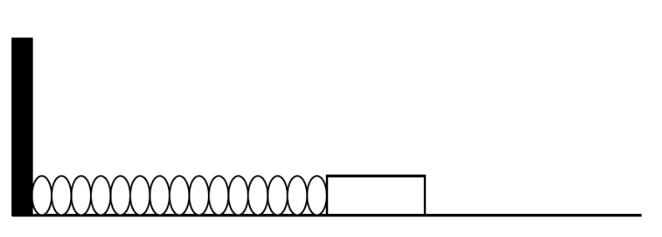

1. A 0.8 kg block is attached to the end of a spring whose spring constant is 85 N/m. The block is placed on a frictionless tabletop, given an initial displacement of 3.5 cm and then released.
2. What type of energy did the block-spring system initially have?
3. Find the magnitude of this energy.
4. How does the total energy of the block-spring system change as the block is pushed across the frictionless surface? Explain.
5. Find the maximum velocity of the block.

**Momentum**

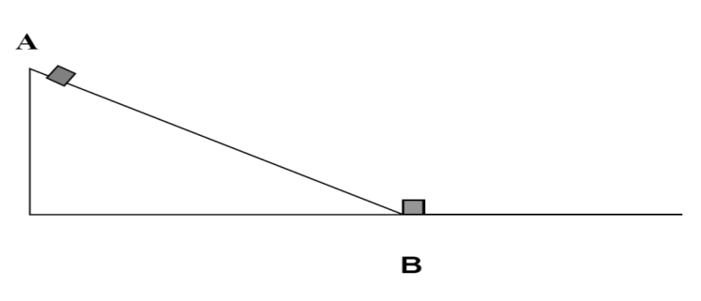

1. A track consists of a frictionless incline plane, which is a height of 0.5 m, and a rough horizontal section with a coefficient of kinetic friction 0.02. Block A, whose mass is1.5 kg, is released from the top of the incline plane, slides down and collides instantaneously and inelastically with identical block B at the lowest point. The two blocks move to the right through the rough section of the track until they stop.
2. Determine the initial potential energy of block A.
3. Determine the kinetic energy of block A at the lowest point, just before the collision.
4. Find the speed of the two blocks just after the collision.
5. Find the kinetic energy of the two blocks just after the collision.
6. How far will the two blocks travel on the rough section of the track?
7. How much work will the friction force do during this time?

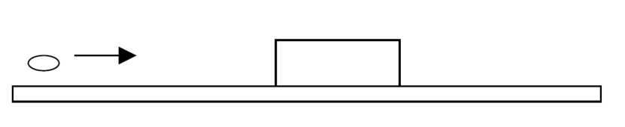

1. A bullet of mass 0.01 kg is moving horizontally with a speed of 100 m/s when it hits a block of mass 2 kg that is at rest on a horizontal surface with a coefficient of friction of 0.4. After the collision the bullet becomes embedded in the block.
2. What is the net momentum of the bullet-block system before the collision?
3. What is the net momentum of the bullet-block system after the collision?
4. What is the speed of the bullet-block system after the collision?
5. Find the total energy of the bullet-block system before the collision?
6. Find the total energy of the bullet-block system after the collision?
7. Is the total energy conserved during the collision?
8. Find the maximum traveled distance of the bullet-block after the collision?

**Fluids**

1. What is the density of an aluminum block with a mass of 4050 kg and volume of 1.5 m3?
2. What is the mass of a rectangular shaped ice block with dimensions of 0.04 $×$ 0.05 0.03 m3 if the density of ice is 917 kg/m3?
3. What is the volume of a wooden board with a mass of 0.6 kg and density of 900kg/m3?
4. A 150 N force is applied to an area of 0.2 m2. What is the pressure due to this force?
5. An aluminum cylinder with a cross-sectional area 0.07 m2 is placed vertically on a table-top. What is the weight of the cylinder if it exerts a 1400 Pa of pressure on the table-top?
6. What is the covered area by a 49 N object that exerts a pressure of 1200 Pa?
7. A 10-cm tall glass is filled with water (density 1000 kg/m3). What is the water pressure at the bottom of the glass?
8. A diver can withstand a maximum pressure of 3105 Pa. What maximum depth he can reach in seawater (density 1025 kg/m3)?
9. What is the gauge pressure if the absolute pressure is 321 atm?
10. A metallic object weighs 50 N in air and 40 N in water. What is the buoyant force of the water?

**Electric Charge and Force**

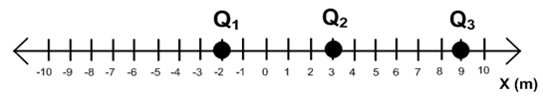

1. A positive charge Q1 = 7.4 μC is located at a point X1 = -2 m, a negative charge Q2 = -9.7 μC is located at a point X2 = 3 m and a positive charge Q3 = 2.1 μC is located at a point X3 = 9 m.
2. Draw free body diagrams for the electric force acting on Q1, Q2 and Q3.
3. Find the magnitude of the force between Q1 and Q2.
4. Find the magnitude of the force between Q1 and Q3.
5. Find the magnitude of the force between Q2 and Q3.
6. Find the magnitude and direction of the net electric force on charge Q1.
7. Find the magnitude and direction of the net electric force on charge Q2.
8. Find the magnitude and direction of the net electric force on charge Q3.

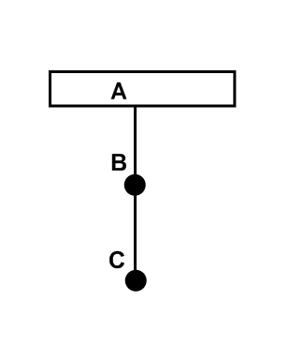

1. Two identical balls (B and C) with a mass of 0.5 g are suspended from two strings as show above. The balls carry equal charges +10 nC each and are separated by a distance of 4 cm.
2. Draw free-body diagram and show all forces applied to ball C.
3. Find the tension force in the string BC.
4. Draw free-body diagram and show all forces applied on ball B.
5. Find the tension force in string AB.
6. Answer questions a, b, c, d for the situation when the balls have equal but opposite charges (charge on B is positive and charge on C is negative).

**Electric Field and Potential**

+Q1 -Q2

-4 -3 -2 -1 0 1 2 3 4 5 6 7 **X(m)**

1. A positive charge, Q1 = +4.6 μC, is located at point x1 = -4 m and a negative charge, Q2 = -3.8 μC, is located at a point x2 = 5 m.
   1. Find the magnitude and direction of the electric force between the charges.
   2. Find the magnitude and direction of the electric field at the origin due to charge Q1.
   3. Find the magnitude and direction of the electric field at the origin due to charge Q2.
   4. Find the magnitude and direction of the net electric field at the origin.
   5. Find the electric potential at the origin due to charge Q1.
   6. Find the electric potential at the origin due to charge Q2.
   7. Find the net electric potential at the origin.
   8. How much work must be done to bring a 1-μC test charge from infinity to the origin?
2. An alpha particle (q = +3.2 x 10-19 C and m = 6.6 x 10-27 kg) is accelerated from rest by a potential difference of 5000 V in a uniform electric field. The potential difference is applied over a distance of 10 cm.
   1. What is the maximum kinetic energy of the alpha particle?
   2. What is the maximum speed of the alpha particle?
   3. What is the electric field strength?
   4. What is the acceleration of the alpha particle?
   5. How long will it take for the alpha particle to travel the 10 cm?

**Current and Circuits**

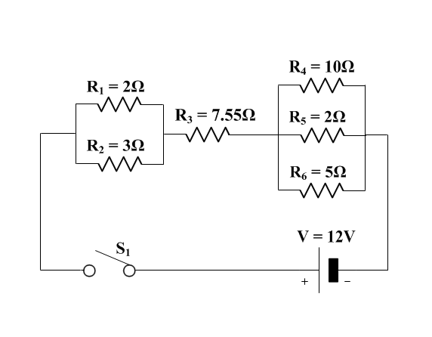

1. Determine the following for the above circuit:
   1. The equivalent resistance of R1 and R2.
   2. The equivalent resistance of R4, R5 and R6.
   3. The equivalent resistance of all six resistors.
   4. The current through the battery.
   5. The voltage drop across R1 and R2?
   6. The voltage drop across R3?
   7. The voltage drop across R4, R5 and R6?
   8. The current through each resistor?

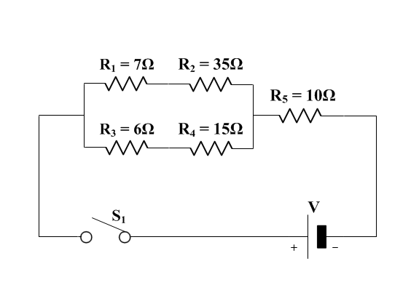

1. In the above circuit, the current through the 7- Ω resistor is 5 A. Determine:
2. The voltage across the 7 Ω resistor.
3. The voltage across the 35 Ω resistor.
4. The current through the 6 Ω resistor.
5. The voltage across the 15 Ω resistor.
6. The current through the 10 Ω resistor.
7. The terminal voltage of the battery.
8. The total power dissipated in the circuit.

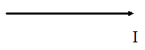**Magnetic Force**

1. A thin 2.4 m long aluminum wire has a mass of 0.15 kg and is suspended by a magnetic force due to a uniform magnetic field of 1.2 T.
   1. On the diagram above show all the applied forces on the wire.
   2. What is the net force on the wire if it is in equilibrium?
   3. On the diagram above show the direction of the magnetic field.
   4. What is the magnitude of the current flowing through the wire?

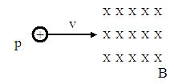

1. A proton is traveling horizontally at a constant speed of 7.4*106 m/s when it enters a uniform magnetic field of 0.46 T (see figure above).
   1. On the diagram above show the direction of the magnetic force on the proton as it enters the magnetic field.
   2. On the diagram above show an approximate path of the proton.
   3. Calculate the magnitude of the magnetic force on the proton.
   4. Calculate the acceleration of the proton.
   5. Calculate the radius of the path that the proton follows in the magnetic field.

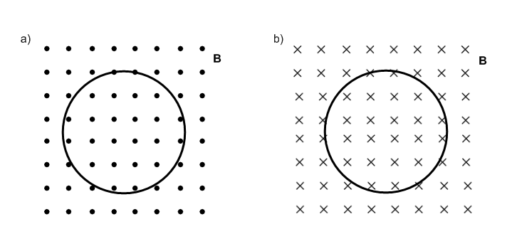**Electromagnetic Induction**

1. A circular coil with a radius of 25 cm has 20 turns. The coil is oriented perpendicularly to a magnetic field whose initial magnitude is 3.2 T. Suddenly, the magnetic field vanishes in 0.4 s.
   1. What is the initial magnetic flux in the coil?
   2. What is the induced emf in the coil?
   3. If the net resistance of the coil is 6.8 Ω what is the magnitude of the induced current in the coil?
   4. What is the direction of the induced current in the coil?
   5. What is the rate of thermal energy generated by the coil?

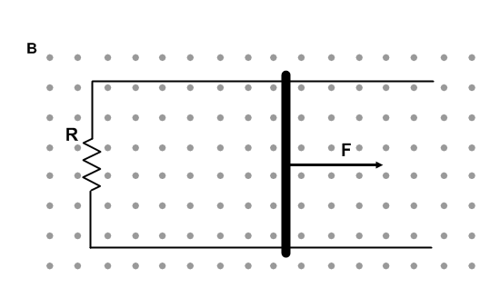

1. A conducting rod with a length of 0.45 m makes a contact with two conducting and parallel rails. The rails are connected to a 2.5 Ω resistor; ignore the resistance of the rod and rails. A constant force F moves the rod at a constant speed 4.2 m/s to the right with no friction between the rod and rails. The apparatus is placed in a uniform magnetic field 1.8 T that is perpendicular to the rails and the rod.
   1. Calculate the induced emf in the rod.
   2. Find the direction of the induced current in the resistor.
   3. Calculate the magnitude of the induced current in the resistor.
   4. Calculate the power dissipated in the resistor during the time when the rod moves in the field.
   5. Calculate the external force necessary to move the rod at constant speed through the magnetic field.

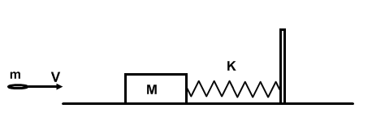**Simple Harmonic Motion**

1. A bullet m = 0.001 kg moves with a speed of 500 m/s and strikes a block M = 2 kg at rest. After the collision the bullet becomes embedded into the block. The block is attached to the end of a spring k = 120 N/m.
2. What is the initial kinetic energy of the bullet?
3. What is the speed of the bullet-block system after the collision?
4. What is the kinetic energy of the bullet-block system after the collision?
5. What is the maximum elastic potential energy when the block comes to rest?
6. What is the maximum compression of the spring?
7. What is the period of oscillations?

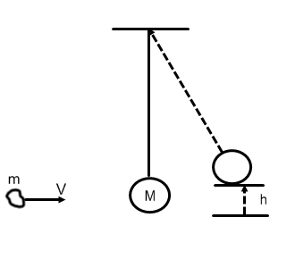

1. A piece of clay m = 0.04 kg has a speed of 15 m/s as shown above. The clay strikes a pendulum bob M = 0.5 kg and sticks to it. The pendulum bob is attached to a string that is 0.5 meters long. As a result of the collision the pendulum swings to the right and the bob moves up by distance h.
2. What is the initial kinetic energy of the clay?
3. What is the speed of the clay-bob system after the collision?
4. What is the kinetic energy of the clay-bob system after the collision?
5. What is the maximum gravitational potential energy of the clay-bob system?
6. Find the maximum height of the bob after the collision.
7. What is the period of oscillations?

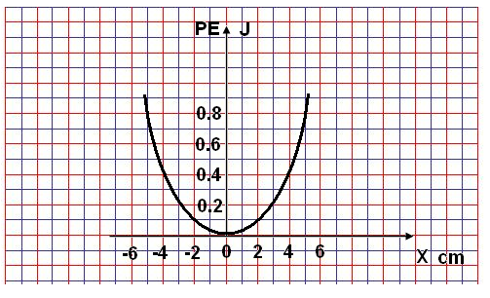

1. A 0.5 mass is attached to a horizontal spring which undergoes SHM. The graph of EPE as a function of position show above. The total energy of the oscillating system is 0.8 J.
   1. Draw the graph of total energy as a function of position.
   2. Draw the graph of kinetic energy as a function of position.
   3. What is the maximum displacement of the oscillating mass?
   4. What is the potential energy at the position of 2 cm?
   5. What is the kinetic energy at the position of 2 cm?
   6. Find the location of the oscillating mass when its potential energy is 0.7 J.
   7. What is the period of oscillations?

**Waves**

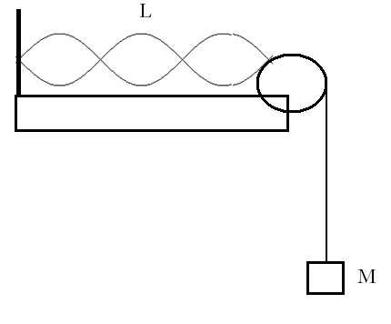

1. A string with a length of 1.5 m resonates in three loops as shown above. The string linear density is 0.03 kg/m and the suspended mass is 1.2 kg.
2. What is the wavelength?
3. What is the wave speed?
4. What is the frequency of oscillations?
5. What will happen to the number of loops if the suspended mass is increased?

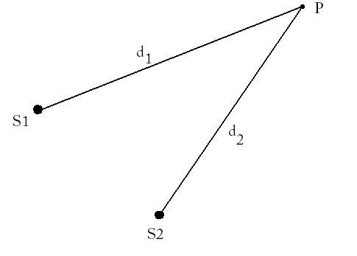

1. Two waves on the surface of water are generated by two independent sources vibrating at the same frequency 4.0 Hz. The waves travel at a speed of 3.2 m/s. A point P is located 4.2 m from source 1 and 4.6 m from source 2.
2. What is the wavelength of the waves?
3. What is the extra distance traveled by the second wave before it reaches point P?
4. What is the result of the interference at the point P?
5. What will be the result of interference at the point P if source 2 is moved 1.2 m further back?
6. What will be the result of interference at the point P if source 2 is moved 1.6 m further back?

**Sound Waves**

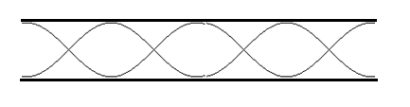

1. A sound wave resonates in a pipe open on both ends as shown above. The length of the pipe is 2.4 m.
   1. Which harmonic is shown in the pipe?
   2. What is the wavelength of the sound?
   3. What is the fundamental frequency?
   4. What is the third harmonic?

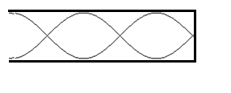

1. A sound wave resonates in a pipe closed on one end as shown. The length of the pipe is 1.5 m.
   1. Which harmonic is shown in the pipe?
   2. What is the wavelength of the sound?
   3. What is the fundamental frequency?
   4. What is the fourth harmonic?

**Electromagnetic Waves**

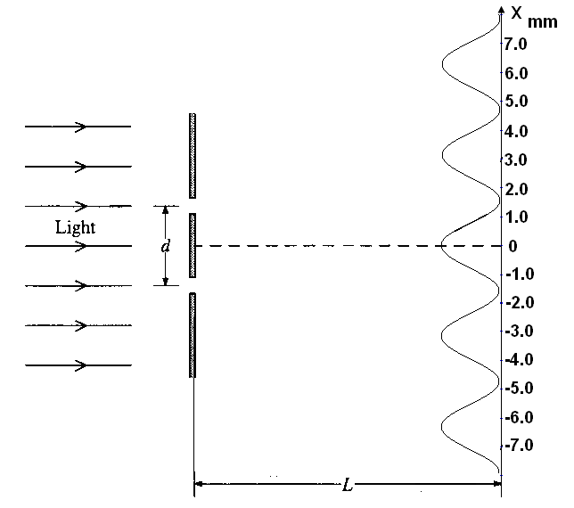

1. Monochromatic light strikes a double-slit apparatus as shown above. The separation between the slits is 0.4 mm. As result of diffraction an interference pattern is produced on the second screen 4 m away.
   1. What property of light does this experiment demonstrates?
   2. Find the wavelength of the incident light based on the interference pattern.

The double-slit apparatus is submerged into water (n = 1.33)

* 1. What is the frequency of the light in water?
  2. What is the wavelength of the light in water?
  3. What happens to the distance between two adjacent fringes in water?

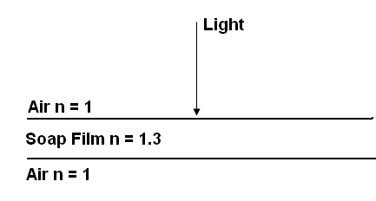

1. A soap film is illuminated with monochromatic light wavelength of 600 nm as shown above.
   1. What is the frequency of the incident light in vacuum?
   2. What is the frequency of light in the film?
   3. What is the speed of light in the film?
   4. What is the wavelength of light in the film?
   5. Calculate the minimum thickness of the film required to produce no reflected light.
   6. Calculate the minimum thickness of the film required to produce maximum intensity of the reflected light.

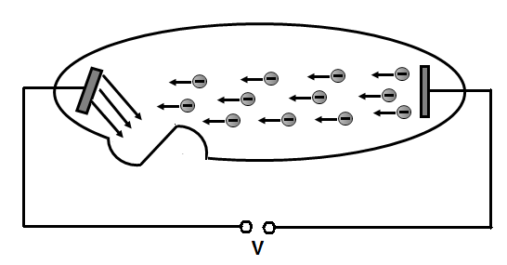

**Quantum Physics**

1. In an X-ray tube an accelerating voltage of 70,000 V is applied to accelerate electrons to high energies. (e = 1.6*10-19 C, me = 9.1*10-31 kg).
2. What is the maximum kinetic energy of the accelerated electrons?
3. What is the maximum speed of the accelerated electrons?
4. What is the energy of the emitted X-ray photons?
5. What is the frequency of the emitted X-ray photons?
6. What is the wavelength of the emitted X-ray photons?
7. The electron energy in an atom can be determine by the following formula En = Z2E1/n2.(Z – atomic number, E1 = -13.6eV – lowest energy of hydrogen atom, n – quantum number).
8. What are the first four energies of the hydrogen atom?
9. What is the frequency of the emitted photon if the electron makes a transition from n = 3 to n = 2.
10. What is the wavelength of the photon for the same transition?
11. Would the emitted photon be visible?

**Nuclear Physics**

1. 126C is an isotope of carbon. What is the atomic number? What is the atomic mass number?
2. 42He is an isotope of helium. Calculate the defect mass and the binding energy of this isotope (mass of isotope helium 42He is 4.002602 u, mass of neutron is 1.008665 u, mass of isotope hydrogen 11H is 1.007825 u).
3. Fill the missing component of the following equation:

20883Bi 🡪42He +?

1. Fill the missing component of the following equation:

3215P 🡪3216S +?

1. An isotope of Bi has a half-life time of 2 min. How much radioactive material will be left after 8 min from a starting sample of 100 g?
2. An isotope of 21082Pb has a half-life time of 22 years. How much radioactive material will be left after 110 years from a starting sample of 8 kg?
3. Calculate the defect mass of the following reactions:
   1. 2713Al + 10n🡪42He +?
   2. 126C + 11H🡪136C +?
   3. ?+ 11H🡪2211Na +42He
4. Calculate the energy involved in the following reactions:
   1. 5525Mn +?🡪5526Fe +10n
   2. 168 O+ 42 He 🡪 γ +?
   3. 21H + 31H🡪42He +?
   4. 73Li + 21H🡪 ? +10n

**Geometric Optics**

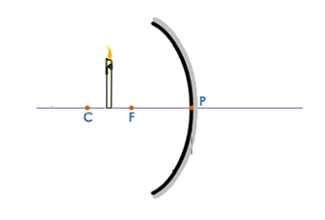

1. A candle is placed at a distance of 15 cm from of a concave mirror with a focal length of 10 cm. The candle is 4 cm tall.
   1. On the diagram below use ray-tracing to show the image produced by the mirror.
   2. Find the image distance. Is the image real or virtual?
   3. Find the size of the image. Is the image upright or inverted?

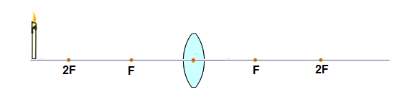

1. An object is placed at a distance of 80 cm from a converging lens with a focal length of 30 cm.

a. On the diagram below use ray-tracing to show the image formed by the lens.

b. Calculate the image distance. Is the image virtual or real?

c. If the object is 8 cm tall, what is the size of the image?