Compounds: Chapter Problems

Chemical Formulas
Class work
- How many sulfur atoms are in 0.25 moles of Sulfur?
- How many moles of boron are in 3.79x10²⁴ atoms of Boron?
- What is the molar mass of N₂O₅?
- How many grams are in 1.34 moles of Aspirin (C₉H₈O₄)?
- How many grams are in a 10 L tank of Propane (C₃H₈) at STP?
- How many atoms of sulfur are in a 34 gram sample of sodium sulfate?
- Bauxite is an aluminum rich ore that is approximately 23.7% aluminum ion by mass. How many ions of aluminum are in a 24.5 gram sample of bauxite?
- Which contains the greater number of moles of each ion/element listed: [NO₃- ion] 3 x 10²³ formula units of Mg(NO₃)₂ or 100 mL of 2 M Al(NO₃)₃
- Write the empirical formula for C₂H₄O₂.
- Calculate the percent by mass of carbon, hydrogen, and chlorine in DDT, C₁₄H₉Cl₅
- Compare the percent by mass of chromium in CrO and Cr₂O₃
- Stannous fluoride is added to toothpaste to help prevent tooth decay. What is the empirical formula for this compound if it is 24.25% F and 75.75% Sn by mass?
- Propylene (a precursor compound for plastics we make on earth) was recently discovered in the atmosphere of Saturn’s moon Titan. When analyzed, the sample of propylene was found to be 85.7% carbon by mass with a molecular weight of 42 u. What are the empirical and molecular formulas of propylene?
- A nitrogen oxide is created when 5.6 L of N₂ gas reacts with O₂ gas at STP to produce 11 grams of product. How many grams of nitrogen gas reacted? How many grams of oxygen gas reacted? What is the empirical formula of the oxide?
- The mass spectrum of an unknown organic compound indicated prominent peaks on the mass spectrum at 216 and 218 u of roughly equal intensity. The compound, consisting of C, H, O, and Br was assessed to be 73% bromine by mass. When a 31.2 gram sample was combusted in air, 6.44 L of CO₂ gas was produced @STP along with 3.22 L of water. What is the mass of bromine in the sample? What is the mass of C, H, and O in the sample? What is the empirical and molecular formula of the organic compound? Propose why there are two peaks produced in the mass spectra for this compound of relatively equal intensities?
- Both water and hydrogen peroxide are pure substances. Does the % by mass of hydrogen and oxygen in each vary with the size of the sample? Justify your answer.

Homework
- How many hydrogen atoms are in 4.15 moles of hydrogen gas?
- In a 2 mole sample of butene (C₄H?), there are 9.6 x 10²⁴ atoms of H. What is the missing subscript for the H in the butene molecule?
- What is the molar mass of sucrose (C₁₂H₂₂O₁₁)?
- How many grams are in 2.7 moles of iron (III) nitrate?
- How many grams of acetylene (C₂H₂) are in a 100L tank of acetylene at STP?
- When a wasp stings you it releases into the wound histamine(C₅H₉N₃) which causes an allergic reaction. Assuming a threshold of 3.4 x 10¹⁵ molecules of histamine are necessary to cause a reaction, is a human at risk of a reaction if they were stung with a 0.00056 gram amount of histamine?
- At STP what would be the volume of 100g of sulfur hexafluoride?
- Which contains the greater number of moles of each ion/element listed: [NH₃(g)] 0.76 L of NH₃ @STP or 670 mg of NH₃
- Write the empirical formula for H₂NCH₂CH₂NH₂
- Is it possible to determine the molecular formula of a compound solely from its percent composition? Explain.
- In terms of nitrogen percentage, which of the following would be the best fertilizer: ammonium sulfate [(NH₄)₂SO₄], potassium nitrate [KNO₃], or sodium nitrate [NaNO₃]?
- A mixture of table salt (NaCl) and water has a total mass of 345 grams. Upon analysis, it was determined that 48 grams of oxygen were present in the sample. How many grams of each of the following MUST also be in the sample: hydrogen; sodium; chloride
- What is the empirical formula of the compound formed when 9.33 g of copper metal reacts with excess chlorine to give 14.54 g of the compound?
- Beta carotene is a building block of vitamin A. Calculate the molecular formula for beta carotene if the compound is 89.49% C and 10.51% H by mass and its molecular weight is 536.89 g/mol.
- An organic compound containing carbon, hydrogen and chlorine was combusted in air and found to produce 0.225 grams of carbon dioxide and 0.0921 grams of water. Assume the initial mass of the organic compound was 0.43 grams. How many grams of carbon and hydrogen were in the organic compound? What is the % by mass of chlorine in the compound? What is the empirical formula of the compound?
- An entrepreneur says they have discovered a vein of pure CuO in a particular region of the Rocky Mountains. How would you propose verifying that her claim is true - that the CuO is in fact pure? Support your proposal by citing expected results from your experiment if the sample were pure vs. impure.

Metals & Alloys
Class work
- Sketch the structure of a solid lithium, including at least 6 atoms.
- Metals tend to have high melting points. Relate this property to the structure of metallic solids.
- Would an alloy obey the Law of Definite Composition? Explain.
- Electrical wiring is typically made from copper or, in the case of high voltage pylons, aluminum. Why is steel or bronze never used to make electrical wiring?
- Create a concept map or flow chart that describes the relationships between the different types of alloys.
- Distinguish substitutional alloys from interstitial alloys.
- Sketch the structure of a homogeneous substitutional alloy. How would this differ from a heterogeneous alloy?
- Tin is too soft to be used by itself for practical purposes. It has been alloyed at different times with lead, antimony and copper to form metals collectively known as pewter. In all cases, it retains the crystalline structure of tin. What types of alloys are these?
- Stainless steel is an example of a substitutional/interstitial alloy. It is an alloy of iron; chromium, nickel, and carbon have been added. What added elements are substitutional? Which are interstitial? Explain.

Homework
- Metals are malleable and ductile. Relate these properties to the structure of metallic solids.
- Metals conduct electricity when solid while ionic compounds only conduct electricity when molten or aqueous. Explain this difference in properties.
- Distinguish homogenous alloys from heterogeneous alloys.
- Sketch a homogeneous interstitial alloy. How would this differ from an intermetallic alloy?
- What must occur to create a combination substitutional/interstitial alloy?
- Alloying metal requires a large energy input. What are the benefits of metal alloys over pure metal?
- Some early human tools have been found to be made from meteoric iron, a naturally occurring homogeneous alloy of nickel and iron. What type of alloy is this? Explain.
- In ancient civilizations gold was often alloyed with silver to produce “colored gold”. What type of homogenous alloy is this? Explain.

Ionic Compounds
Class work
- Explain why different ionic compounds form different crystal lattice structures.
- Sketch the structure of solid lithium chloride. Include at least 12 formula units.
- Ionic compounds are brittle. Relate this property to the structure of ionic compounds.
- Justify the following statement: Overall, ionic bond formation is exothermic.
- Define lattice energy.
- Explain the following trend in lattice energy: MgF₂ > MgCl₂ > MgBr₂ > MgI₂.
- Predict which has the higher melting point: CuCl or CuCl₂. Explain your reasoning.

Homework
Use the following website to answer questions 73-77
http://www.webelements.com/compounds/
- Sketch the structure of solid magnesium chloride. Include at least 15 formula units.
- Sketch the structure of solid sodium sulfide Include at least 8 formula units
- Ionic compounds have high melting points. Relate this property to the structure of ionic compounds.
- Write the reaction for the lattice energy of calcium bromide.
- Which of the following compounds has the largest lattice energy: NaF, NaCl, NaBr, NaI?
- Use lattice energies to explain why MgO is much less soluble in water than is CaO.

Covalent Compounds
Class work
- Compare and contrast properties of covalent network solids with the properties of metals and salts. Use the structure of CNS to justify your response.
- Define “doping”.
- Discuss the effect of adding selenium to silicon.
- Both molecular solids and covalent network solids are composed of elements from right side of the periodic table. Distinguish these types of solids from each other in terms of structure and properties.
- Justify the following statement: The bond between atoms of O and C is referred to as being polar covalent.
- The amount of energy (enthalpy) required to break the bond is a measure of bond strength. The bond enthalpy of oxygen gas is 495 kJ/mol. The bond enthalpy of nitrogen gas is 941 kJ/mol. Relate the difference in these energies to the structure of these compounds.
- Predict which diatomic gas would have a higher bond enthalpy: Cl₂ or Br₂. Justify your prediction.
- Discuss the relationship between bond length and bond enthalpy.
- Using the graph below, what is the approximate bond length for these atoms represented in the diagram? Why does the potential energy of the atoms increase sharply as the inter-nuclear distance becomes very small?
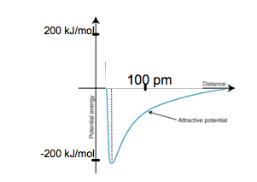
- How many valence electrons are in ZrF₇³⁻?
- Write the Lewis structure for NH₃.
- Write the Lewis structure for H₃O⁺.
- Write the Lewis structure for C₂H₆.
- Using Lewis structures, explain why the C-O bond enthalpy in carbon monoxide is 1072 kJ/mol while the C-O bond enthalpy in carbon dioxide is 732 kJ/mol.
- Draw all of the possible Lewis structures for the CO₃²⁻ ion.
- Which of the following molecules or ions has resonance structures: HCO₂⁻, PH₃, HCN.
- Sulfur trioxide and the sulfite ion have the same number of atoms but different structures and properties. Draw the correct Lewis structure for both. Compare the S-O bond lengths in both molecules.
- Write the formula for formal charge.
- Why is there a pi bond in the sulfite ion? Explain using the concept of formal charge.
- State the equation for bond order.
- What is the bond order of the central atom in carbon dioxide?
- What is the bond order of the central atom in methane?
- Compare the bond orders of the central atoms in carbon dioxide and methane. Which has higher bond enthalpy?
- Look back at your Lewis structure for sulfur trioxide. Are all of the bonds in sulfur trioxide the same length? Explain your answer.
- Distinguish pi bonds from sigma bonds.
- What is the hybridization of the S atom in sulfur trioxide and the sulfite ion?
- What is the hybridization of the N atom in the ammonium ion?
- What is the hybridization of S atom in SF₆?
Homework
- Sketch the structure of diamonds and graphite. You these structures to explain the difference in hardness between these two substances.
- Define semiconductor.
- Discuss the effect of adding gallium to silicon.
- Air is composed mainly of oxygen gas, nitrogen gas, and carbon dioxide gas. What type of compounds are these? How can you determine this based solely on their state?
- How do covalent bond differ from ionic bonds?
- The average single bond energy for O-H is 467 kJ/mol. The average single bond energy for O-Cl is 203 kJ/mol. The average single bond energy for H-Cl is 427 kJ/mol. Relate the differences in these energies to the structure of these atoms.
- Predict which bond would have a higher bond enthalpy: C-O or C-Cl. Justify your prediction.
- Discuss the relationship between number of bonds and bond length.
- H₂ has a bond length of 74 pm and a bond enthalpy of 432 kJ/mol. Sketch a graph of bond length vs. bond enthalpy for this compound.
- How many valence electrons does SiF₆²⁻ have?
- Write the Lewis structure for CH₄.
- Write the Lewis structure for BH₄⁻.
- Write the Lewis structure for C₂H₄.
- The nitrogen-to-nitrogen bond lengths in the following compounds are: N₂ 0.110 nm; HNNH 0.125 nm; H₂NNH₂ 0.146 nm. Explain these bond lengths using Lewis structures.
- Draw all of the possible Lewis structures for SCN⁻ ion.
- Which of the following molecules do not have possible resonance structures: C₂H₂, CHCl₃, SO₃.
- Justify the following statement: All C-O bonds in the carbonate ion are the same length.
- Look back at your Lewis structures for sulfur trioxide and the sulfite ion. What is the formal charge on the central atom in each structure?
- How is formal charge used to determine the correct Lewis structure?
- What is the bond order of the phosphorus atom in PH₃?
- What is the bond order of the carbon atom in the carbonate ion?
- What is the bond order of an oxygen atom in an oxygen molecule?
- If the S-O bond lengths are about the same in SO₂ and SO₃, what can be said about the bonding in these two compounds?
- Use bond order to explain why the bond length in nitrate ions is longer than in nitrite ions.
- What does hybridization mean in chemistry?
- What is the hybridization of the P atom in PH₃?
- What is the hybridization of the C atom in carbon monoxide?
- What is the hybridization of the Xe atom in XeF₄?
Molecular Geometry
Class work
- How will the valence pairs of electrons in Neon arrange themselves around the nucleus? Explain.
- State the molecular geometry of CH₄.
- State the molecular geometry of SO₄²⁻.
- State the molecular geometry of AsF₅.
- What is the O-S-O bond angles in both sulfur trioxide and in the sulfite ion?
- XeF₂ and OF₂ are two rare molecules. Draw the Lewis structures for both molecules. Explain why the bond angles in XeF₂ are larger than the bond angles in OF₂.
- Explain why carbon dioxide has no dipole moment.
- Which of the following molecules is/are polar: CH₃OH, H₂O, CH₃OCH₃?
- N₂O, otherwise known as laughing gas, in used as an anesthetic. Would the molecule be expected to have a large or small dipole moment? Justify your answer.
Homework
- If there are three pairs of electrons around a central atom, how will these three domains arrange themselves? Does the configuration change if these domains are bonds rather than lone pairs?
- State the molecular geometry of SF₄.
- State the molecular geometry of I₃⁻.
- State the molecular geometry of XeF₄.
- What are the bond angles for ammonia and the ammonium ion?
- The bond angles in BCl₃ are 120º. The H-C-H bond angles in H₂CCH₂ are 121º. Explain this difference using the electron domain model.
- Which two factors influence the polarity of a molecule?
- Explain why OCS is a polar molecule but CS₂ is not.
- Which of the following molecules is/are polar: BF₃, C₂H₆, CH₂OH?

Intermolecular Forces
Class work
- What factors increase the strength of London dispersion forces?
- How do molecules with a permanent dipole behave in the presence of ions?
- List all of the types of intermolecular forces found between SO₂ molecules.
- List all of the types of intermolecular forces found between CH₂OH molecules.
- Some molecules are said to by hydrophilic (water-loving). What type of intermolecular forces are likely present in these molecules?
- How does molecular geometry affect the state of matter at room temperature?
- Explain the following trend in boiling points: HCl 110 ºC; HF 19.5 ºC; HBr -66 ºC; HI -35.4 ºC
- Water (H₂O) has a boiling point of 100 ºC and hydrogen peroxide (H₂O₂) has a boiling point of 150.2 ºC. Explain the difference in boiling points in terms of molecular structure.
- Predict the order in which the boiling points of the following compounds would increase: CO₂, CH₄, CH₂COOH, CH₃Cl. Justify your predictions.
- A molecule is a gas a room temperature (21 ºC). What could be inferred about its molecular structure?
Homework
- What type of intermolecular force is present in all molecules?
- What factors increase the strength of dipole-dipole forces?
- What features are necessary for a molecule to exhibit hydrogen bonding?
- List all of the types of intermolecular forces found between ICl₃ molecules.
- List all of the types of intermolecular forces found between SF₄ molecules.
- Is it possible for a molecule that only experiences London dispersion forces to have a higher boiling point than a molecule that experiences hydrogen bonding?
- Explain the following trend in boiling points: CO₂ -78.5 ºC; NO₂ 21 ºC; SO₂ -10 ºC; O₃ -112 ºC
- Predict the order in which the boiling points of the following diatomic molecules would increase: N₂, O₂, F₂, Cl₂, Br₂, I₂. Justify your prediction.
- A molecule has a similar mass to water but a higher boiling point. What can be inferred about its molecular structure?
- Sucrose and starch are both molecular solids at room temperature. Explain why.

States of Matter
Class work
- Why does heating a material at a constant pressure result in a phase change?
- Br₂(s) melts at -7.2 ºC, KBr(s) melts at 734 ºC and K(s) melts at 64 ºC. Explain, in terms of types of material and particle interactions the vast differences in melting points amongst these solids.
- Consider the properties of density and viscosity. Explain what happens to the measured magnitude of these properties when iron metal freezes in a cast.
- A substance has a high melting point and only conducts electricity when dissolved in water. What types of compound is it?
- A substance is liquid at room temperature and does not conduct electricity. What type of compound is it?
- Kinetic molecular theory describes the behavior of ideal gases. What are the assumptions of ideal gases?
- State the equation for converting degrees Celsius to Kelvin.
- There are 3 balloons each filled to the same volume at 22⁰C and 1.0 atm. One balloon contains fluorine gas, one balloon contains oxygen gas, and one balloon contains neon gas. Compare the average kinetic energies of the gas molecules in the three balloons.
- Why does increasing the temperature of a gas increase its pressure (assuming all other factors are constant)?
- A gas is placed in a container with a movable piston. If the container is heated, what will happen to the piston?
- The volume of a gas container is decreased by half. How is the pressure affected?
- Use calculations to justify why one mole of an ideal gas occupies 22.4 L of space at standard temperature and pressure.
- Calculate the temperature at which 1.5 g of O₂ has a pressure of 0.97 atm in a 1.0 L container.
- Calculate the pressure in an evacuated 250 mL container at 0 ºC when the O₂ in 1 L of liquid oxygen evaporates. Liquid oxygen has a density of 1.118 g/L.
- What is the volume of the gas in a balloon at -195 ºC if the balloon has been filled to a volume of 5.0 L at 25 ºC?
- What is the relationship between mass and rate of effusion?
- There are 3 balloons each filled with the same volume of gas at STP. One balloon contains helium gas, one balloon contain oxygen gas, and one balloon contains argon gas. Which balloon would have the greatest volume after 24 hours? Explain.
- How does the velocity of carbon dioxide gas effusion compare to methane gas?
- A gas is found to diffuse 16 times faster than ammonia. What is its mass?
- Which of the following diatomic gases would behave most like an ideal gas: H₂, O₂, N₂, or Cl₂? Explain your response
Homework
- How are intermolecular forces affected by phase changes?
- In its liquid state, which would you expect to be more viscous, water or iodine? Justify your response.
- Consider the properties of density and viscosity. Explain what happens to the measured magnitude of these properties when liquid water is heated from 10 ºC to 30 ºC
- A substance has a high melting point and does not conduct electricity. What type of compound is it?
- A substance conducts electricity as a solid and is shiny. What type of compound is it?
- Convert room temperature (21 ºC) to Kelvin.
- Kinetic molecular theory is a theoretical construct used to explain the behavior of ideal gases. Why do some gases not behave ideally?
- Agree or disagree with the following statement: All gas molecules have the same velocity. Justify your response.
- How does increasing the number of moles of a gas affect the temperature of a gas? The pressure of the gas? (Assume all other factors are kept constant)
- Relate the density of gases to their volume.
- Use the kinetic molecular theory of gases to explain why the pressure of a gas is inversely proportional to its volume.
- The pressure on an ideal gas at standard temperature is increased from 1 atm to 2 atm. What is the resulting volume of the gas?
- The temperature of a gas is decreased by a third. How is the pressure of the gas affected? (Assume all other factors are constant)
- Calculate the pressure (in atm) of 88g of CO₂ in a 30 L container at 23 ºC.
- Calculate the density of CH₂Cl₂ in the gas phase at 40 ºC and 1.00 atm.
- 10.0 L of oxygen gas was collected at 120 ºC and 0.986 atm. Calculate the volume of the gas when it is cooled to 0 ºC and stored in a container at 1.00 atm.
- Define diffusion and effusion of gases.
- Rank the following gases in term of their rate of effusion: argon; chlorine gas; sulfur dioxide; sulfur hexachloride.
- Calculate the mass of unknown gas that take 6 seconds to effuse from a container, when the same volume of helium gas took only 2 seconds.
- Explain why real gases behave more ideally at low pressures and high temperatures.
- Which gases would behave less ideally: carbon dioxide or nitrogen dioxide? Explain you reasoning.
Introduction to Solubility
Class work
- Explain the phase “like dissolves like”.
- A sample taken from a factory contains carbon tetrachloride (CCl₄). The carbon tetrachloride can be extracted by mixing the sample with a solvent the CCl₄ will dissolve in. Which solvent (CH₃OH or C₆H₁₄) would be better suited to extract the CCl₄? Explain your reasoning.
- The solubility of N₂O in water is just 0.15 g/100 mL water @20C. Explain what the low solubility of N₂O in water tells you about the dipole moment of the molecule.
Homework
- Given the following molecules: C₂H₂, H₃COH, CH₃NH₂, IF_{3,} rank the substances chosen from most to least soluble in water. Explain your reasoning.
- Would ionic compounds be considered hydrophilic? Explain.
- You are given an unknown compound. How would you determine the identity of this compound?

Free Response

- Silver ions react with chloride ions in aqueous solution to form a silver chloride solid (precipitate).
  - How many silver ions would be present in a 0.36 gram sample of solid silver sulfate (Ag₂SO₄)?
  - How many grams of aluminum chloride (AlCl₃) will need to be dissolved in water to react with the silver ion amount found in part “a” assuming the product of the reaction of silver and chloride ions is AgCl(s)?
  - Describe the properties of silver chloride. Explain these properties in terms of the compound’s structure.
  - Discuss why silver chloride does not dissolve in water.

- A student purchases hydrogen peroxide from two different suppliers and then analyzed the % oxygen by mass in each. The data is below:

Supplier % by mass oxygen in sample
A 90%
B 93%

  - Considering that the formula for hydrogen peroxide is H₂O₂, how would you prove that neither of these samples is pure hydrogen peroxide?
  - Assuming the other substance present is water (H₂O), which sample contains a greater % of hydrogen peroxide? Justify your answer.
  - What type of compound is hydrogen peroxide? Describe its properties.
  - Hydrogen peroxide decomposes into water and oxygen gas. If the student purchases 100 mL of hydrogen peroxide from supplier A (density = 1.45 g/mL). How many moles of oxygen gas are produced by the decomposition of this sample?
  - What is the volume of oxygen gas produced in part “d” at STP?

- Iron can form different oxides. Using the data below:
Oxide of iron % by mass iron
A 77.73%
B 69.94%

  - Both oxide consist of iron cations and oxide anions. Which oxide contains the iron ion with the higher + charge? Justify your answer.
  - How many oxide anions are present in a 48 gram sample of oxide B?
  - The melting point of oxide A is 1377ºC and the melting point of oxide B is 1566ºC. Convert these temperatures to Kelvin. Postulate why oxide B has a higher melting point.
  - What tests can be done to determine that iron oxide is an ionic compound?

- Both methane (CH₄) and diamond (C) contain the element carbon but the two have very different melting points.
  - Which of the two would have a higher melting point and why?
  - The substances are similar in that neither is a good conductor compared to solid copper. Explain why methane and diamond are poor conductors while copper is a good conductor.
  - Draw the Lewis structure of methane and state it’s molecular geometry.
  - Is methane a more ideal or less ideal gas than ammonia? Explain your reasoning.

- For the following, agree or disagree with the statement and justify your reasoning:
  - CuCl₂(s) is an excellent conductor of electricity
  - I₂(s) has a higher melting point than F₂(s) because I atoms have a greater atomic radii.
  - A solid chunk of wax (C₅₀H₁₀₂) consists of many wax molecules held together by relatively weak intermolecular forces.
  - When KCl(s) melts, intermolecular forces are stretched.
  - Na will have a lower melting point than Mg
  - Liquids have a similar density to gases compared to solids
  - Liquids and gases have smaller viscosities than do solids
  - There are no intramolecular forces in a covalent molecular solid

- Potassium chlorate (KClO₃) can be decomposed at high temperatures into potassium chloride and oxygen gas:
  - Write the balanced chemical reaction
  - If 61 grams of potassium chlorate are decomposed @ 615 torr and 12 C, and the resulting oxygen gas was collected over water; assuming water has a partial pressure of 14.2 mm Hg @12 C ….
    - What was the pressure of dry gas collected?
    - How many L of oxygen gas would be theoretically collected?
    - How many moles of water vapor must have been in the mixture?
    - What would have been the relative speed of oxygen gas compared to that of the water vapor in the collection bottle?

- . Two containers of equal volumes are shown below.
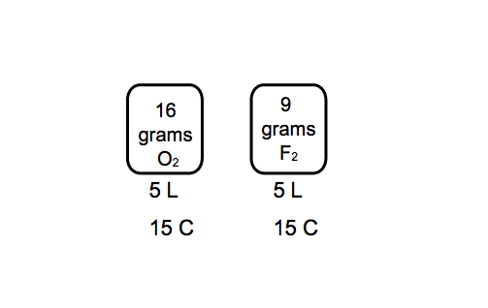
  - Compare the densities of the gases. Explain your reasoning.
  - Compare the average kinetic energy of the gas molecules. Explain your reasoning.
  - Compare the pressures of the gases. Explain your reasoning.
  - Compare the average molecular speed of the gases. Explain your reasoning.
  - Which gas sample would behave more ideally? Explain your reasoning.

- A toxic gas has a vapor density 4.5 x that of air which has a density of 1.225 g/L @ 1 atm of pressure and 15 C.
  - What is the molar mass of this gas?
  - Identify the gas based on it being one of the four possibilities (CH₄, C₂Cl₃H, O₂, CHCl₃)
  - Draw the Lewis structure of this compound. What intermolecular forces would affect this molecule?
  - If the temperature were increased by a factor of 3 (in Celsius), and the pressure was increased by a factor of 9, what would be the new density of air under these conditions?

Answers
      - 1.5x10²³ atoms
      - 6.30 mol
      - 108 g/mol
      - 241 g
      - 19.6 g
      - 1.44 x 10²³ atoms of S
      - 1.29 x 10²³ ions of Al³⁺
      - Mg(NO₃)₂
      - CH₂O
      - 47.435%; 2.5589%; 50.006%
      - CrO has a greater percentage by mass; 76.470% vs. 68.421%
      - SnF₂
      - CH₂; C₃H₆
      - 7.0 grams; 4.0 grams; N₂O
      - 22.78 g Br; 3.45 g C, 0.288 g H; 4.682 g O; Empirical = CHOBr Molecular = C₂H₂O₂Br₂; Bromine has two naturally occurring isotopes that are stable with masses of 79 and 81 respectively. Both occur almost equally in nature.
      - No, since they are pure substances the relative amounts of hydrogen and oxygen must not vary regardless of the size of the sample. Being pure, they obey the law of definite composition.
      - 2.50 x 10²⁴ atoms of H
      - 8
      - 342 g/mol
      - 650 g
      - 116 g
      - Yes
      - 15 L
      - 670 mg of NH₃
      - H₄CN
      - No. You also need the molecular weight because the molecular formula could be any whole number multiple of the empirical formula.
      - Ammonium sulfate (21.21% N by mass)
      - 6 grams; 115.4 grams; 175.6 grams
      - CuCl
      - C₄₀H₅₆
      - 0.061 g C, 0.010 g H; 83.4% Cl; CH₂Cl₂
      - CuO must be 77.9% Cu by mass. Test to see if this is true – if the % varies from this, the sample is NOT pure or is NOT CuO
      - Solid lithium
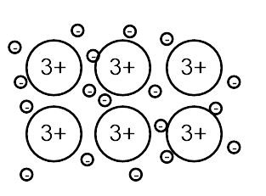
      - Metallic nuclei are surrounded by delocalized electrons. In the solid state, the positively charge nuclei and the surrounding electrons are in close proximity and the Coulombic force between them is very strong. To melt into a liquid the distance between the nuclei and electrons would need to increase. Because of the strong Coulombic attraction a great deal of energy is required to move the electrons away from the nuclei and form liquid metal.
      - No, alloys are mixtures. Two samples of the same alloy do not have to have identical percentages by mass.
      - Alloys are not used in electrical wiring because alloys tend to have lower heat and electrical conductivity than the base metal.
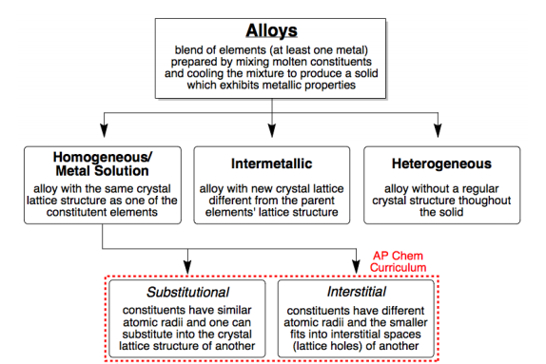
      - Types of alloys
      - Substitutional alloys are alloys of two elements of similar size, usually a metal is added to the base metal. The added element replaces base metal atoms in the matrix. An interstitial alloy is an alloy in which the added element is smaller than the base metal, usually and nonmetal. The atoms of the added element are situated in the interstitial (inbetween) space among the base metal atoms.
      - Heterogenous alloys would not have a consistent crystalline structure.
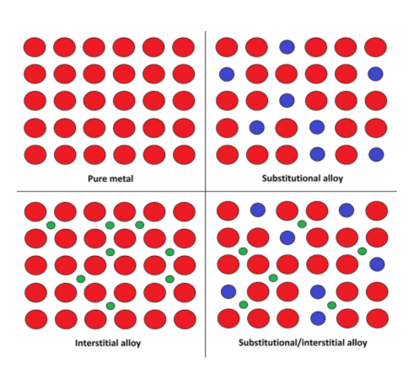
      - Pewter is a substitutional alloy. The base metal is being supplemented with similarly sized metallic atoms.
      - Chromium and nickel would act substitionally being of similar size as the iron. Carbon would filled the interstitial spaces.
      - Metallic nuclei are surround by delocalized electrons. When pressure is applied to the solid the electrons are free to move between and around the nuclei, allowing the solid metal to be resilient when shaped.
      - In metallic solids, electrons are delocalized and able to flow, allowing solid metal to conduct electricity. In ionic solids, the anions are in fixed positions and electricity cannot be conducted. However, when ionic compounds are molten or dissolved in solution, the anions are free to move and electricity can flow.
      - Homogenous alloys have a set crystalline structure. Heterogeneous do not.
      - Intermetallic alloys would have a crystalline structure different from the base metal.
      - To produce a combination alloy, at least two elements must be added to the base metal – one of similar size and one smaller than the base metal atom.
      - Alloys are stronger, less malleable and resist corrosive. Different alloys have different properties. Specific elements can be added to the base metal to enhance specific properties.
      - Nickel and iron are of similar size; this would be a substitutional alloy.
      - Gold and silver are of similar size; this would be a substitutional alloy.
      - The lattice structure of an ionic compound depends on the charges involved. Structures are formed which maximize Coulombic attractions and minimize repulsions.
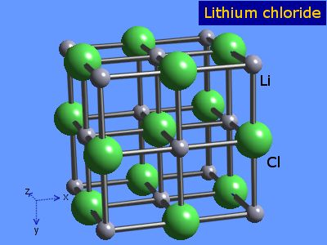
      - LiCl (from webelements.com)
      - Solid ionic compounds are compose of repeating units of anions and cations in a crystal lattice structure. When pressure is applied to the structure, anions and cations move past each other, increasing the repulsive force between these oppositely charged components and the crystal structure breaks into pieces.
      - Ionic bond formation occurs in several steps. While the many of the steps require an input of energy (are endothermic), the final formation of the bond releases energy.
      - Lattice energy is the energy released when ionic compounds are formed from gas phase ions.
      - As the ionic radii increases the Coulombic force between the anion and the cation decrease. Less attractive force equals less lattice energy.
      - CuCl₂. Higher charge typically leads to higher lattice energy. The higher the lattice energy the higher the melting point.
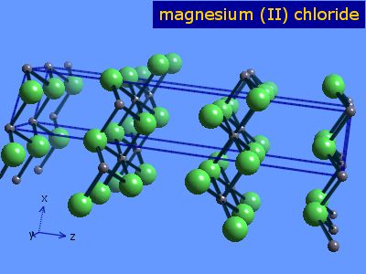
      - Magnesium chloride (from webelements.com)

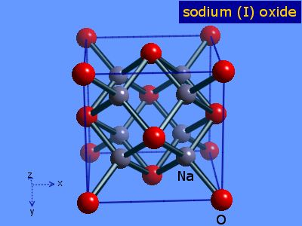
      - Sodium oxide (from webelements.com)
      - Solid ionic compounds have a crystal lattice structure of repeating positively charged cations and negatively charged anions. The Coulombic attraction between these ions is strong and requires a great deal of energy to break. This explains the high melting point of these compounds.
      - Ca²⁺ (g) + 2Br¹⁻ (g) CaBr₂ (s)
      - MgO is less soluble in water than CaO because it has a higher lattice energy. It has a higher lattice energy because the magnesium ion has a smaller atomic radii.
      - NaF
      - Like metals and ionic compounds, covalent network solids are held together by strong electrostatic forces and thus have high melting points. CNS are not good conductors of electricity however because covalent bonds share electrons in fixed states; there is no flow of electrons.
      - Doping is when impurities (other elements) are added to silicon in order to alter its conductive behavior.
      - Adding selenium creates an n-type semiconductor, increasing the silicon’s conductivity.
      - Covalent network solids are much larger than molecules and all atoms are held together by covalent bonds. Molecules have covalent bonds but the majority of the interactions between molecules are intermolecular forces. Covalent networks have a much higher melting point than molecules because of their larger electrostatic force.
      - The bond between carbon and oxygen is polar covalent because while there is an electronegativity difference between these two elements, it is not greater than 1.7.
      - A molecule of oxygen gas consists of two doubly bonded oxygen atoms. A molecule of nitrogen gas consists of two triply bonded nitrogen atoms. The greater the number of bonds the greater the energy required to break the molecule.
      - Cl₂, the smaller the atomic radii the greater the electrostatic force; Coulomb’s law.
      - The smaller the bond length (radii), the greater the electrostatic force. The greater the electrostatic force the greater the bond enthalpy.
      - 33pm. As the distance between the atom decreases, the repulsion between the positively charge nuclei increases significantly.
      - 56
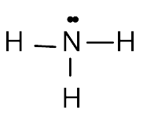
      - NH₃
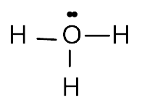
      - H₃O⁺
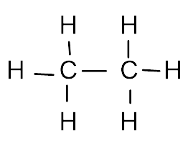
      - C₂H₆
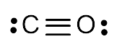
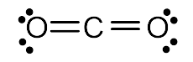
      - The C-O bond in carbon monoxide has higher bond enthalpy because it is triply bonded, while the C-O bonds in carbon dioxide are double bonds. The greater the number of bonds the greater the energy required to break them.
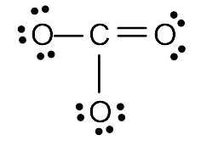
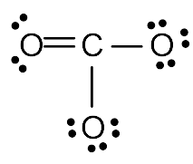
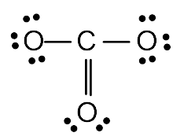
      - CO₃²⁻
      - HCO₂⁻
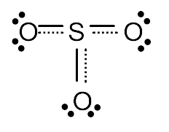
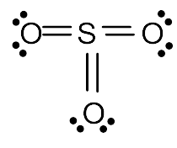
      - Sulfur trioxide has shorter bond lengths than the sulfite ion. The pi electrons are shared by several bonds, these bonds are all of equal length but longer than a non-resonant double bond.
      - Formal charge = number of valence electrons – the number of electrons atom possesses within the Lewis structure.
      - Without the pi bond, sulfur would have a +1 formal charge, with it the formal charge on S is 0, a more stable state.
      - Number of bonds/number of atoms bonded = bond order
      - 2
      - 1
      - Carbon dioxide has the higher bond enthalpy because it has the higher bond order; shorter bonds.
      - Yes they are the same length because they have the same bond order.
      - Pi bonds are created by the overlap of unhybridized orbitals. Sigma bonds are created by the overlap of hybridized orbitals.
      - Both are sp² hybridized.
      - sp³
      - d²sp³
      - Graphite has less bonds than diamonds leading to its softer texture.
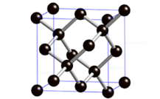
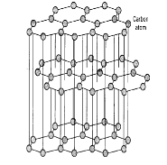
      - Semiconductors are solids with conductivity between an insulator and a conductor; a semi-metal.
      - Adding gallium creates a p-type semiconductor, decreasing the silicon’s conductivity.
      - These are molecules. It can be inferred based on the fact that they are gases at room temperature. Covalent networks, metals, and ionic compounds all have melting points too high to be gases at room temperature.
      - Covalent bonds are the result of nonmetals sharing valence electrons, while ionic bonds are the result of moving electrons from one element to another.
      - These bond enthalpy are the result of differing electronegativities O>Cl>H and radiis O>Cl>H.
      - C-Cl. It is more polar; more polar bonds result in greater electrostatic attractions.
      - The greater the number of bonds the smaller the bond length. Increasing the number of bonds increasing the electrostatic attraction which results in decrease radii.
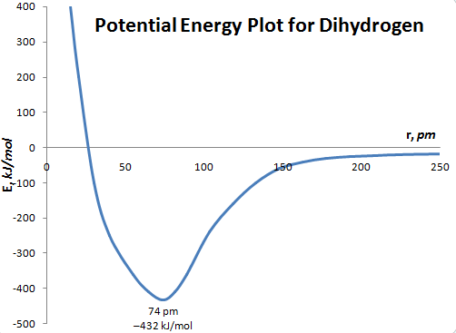
      - H₂
      - 48
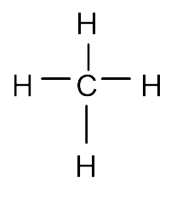
      - Methane
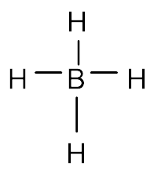
      - BH₄⁻
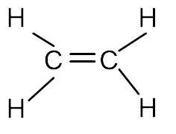
      - C₂H₄
      - N₂ – triple bond; HNNH – double bond; H₂NNH₂ – single bond.
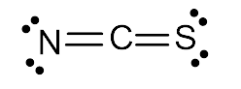
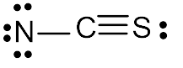
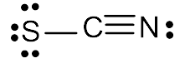
      - SCN⁻
      - C₂H₂, CHCl₃
      - The pi bond electrons in the carbonate ion are shared across all resonance structures so all bonds are of equal length, shorter than single bonds but longer than double bonds.
      - +6 and +4 respectively
      - The most stable Lewis structure in the one in which all atoms have a formal charge of zero.
      - 1
      - 1.33
      - 2
      - The bond order are equal or the ratio of bonds to bonded atoms is equal.
      - The higher the bond order the shorter the bond. Nitrite has a bond order of 3/2 = 1.5; nitrate has a bond order of 4/3 = 1.3. Thus, nitrate’s bonds are longer than nitrite’s bonds.
      - Hybridization in chemistry means the orbitals have combine to create a new orbital.
      - sp³
      - sp
      - d²sp³
      - The valence electron pairs would arrange themselves in a tetrahedral shape to minimize electron-electron repulsions.
      - Tetrahedral
      - Tetrahedral
      - Trigonal bipyramidal
      - 120 degrees and roughly 107 degrees
      - The repulsions of the three unbonded pairs drive the bonded electrons into a linear shape. In OF₂, the 2 unbonded pairs drive the bonded electrons into a bent shape.
      - Carbon dioxide has no dipole moment because it is a linear shape and the electronegativities of the oxygen atoms cancel each other out.
      - CH₃OH and H₂O
      - Small, although the molecule is asymmetrical, the EN difference is not large between O and N (only 0.5)
      - They would form a trigonal planar shape with bond angles of 120º. If all domains are bonds or all lone pairs the molecular shape would remain the same, however if the domains are a combination of lone pairs and shared pairs the lone pairs would experience increased repulsion and increase their surrounding bond angles.
      - Seesaw
      - Linear
      - Square planar
      - 107º due to lone pair and 109.5º
      - Both have 3 domains, but one of the domains in H₂CCH₂ is a double bond allowing the H-C-H bond angle to increase.
      - Polarity of bonds and symmetry of molecule
      - Both molecules have a linear geometry, but OCS is has unbalanced electronegativities (O has greater electronegativity than S)
      - CH₂OH
      - Number of electrons, surface area
      - There would be an ion-dipole intermolecular force.
      - London dispersion and dipole-dipole
      - London dispersion, dipole-dipole, and hydrogen bonding
      - Hydrogen bonding and/or dipole-dipole forces
      - Polar molecules experience dipole-dipole forces which can cause them to be liquids or solids at room temperature,
      - The greater the electronegativity difference between hydrogen and the halogen the more polar the bond; the more polar the bond the greater the dipole-dipole forces resulting in a higher boiling point.
      - Both compounds experience all three intermolecular forces. Hydrogen peroxide has more electrons thus its London dispersion forces are greater resulting in a higher boiling point.
      - CH₄, CO₂, CH₃Cl, CH₂COOH. Methane and carbon dioxide are nonpolar but carbon dioxide has more electrons. CH₃Cl and CH₂COOH are both polar but CH₂COOH would experience hydrogen bonding.
      - It likely has a small mass and is not polar.
      - London dispersion forces
      - Dipole-dipole forces are the result of polarity in the molecule, so higher dipole moments; electronegativity differences will result in greater dipole forces
      - Hydrogen atom bonded to an oxygen, nitrogen or fluorine atom.
      - London dispersion and dipole-dipole
      - London dispersion and dipole-dipole
      - Yes. Large molecules can have large dispersion forces that cause them to have high boiling points.
      - Carbon dioxide and ozone have no dipole moments and thus experience only London dispersion forces. Ozone’s boiling point is lower than carbon dioxide because there is no electronegativity difference between the bonded atoms, making it less polarizable than carbon dioxide. Nitrogen dioxide and sulfur dioxide both experience dipole-dipole forces in addition to LDF, but sulfur dioxide is less polar than nitrogen dioxide.
      - N₂, O₂, F₂, Cl₂, Br₂, I₂. All of these compounds experience only London dispersion forces so boiling point will increase with number of electrons/surface area.
      - It experiences greater hydrogen bonding than water.
      - These molecules experience a great amount of intermolecular forces. They are large structure which leads to high London dispersion forces, in addition they have –OH groups which allow them to experience hydrogen bonding.
      - As the molecules gain energy, they are able to overcome the Coulombic attractions holding the molecules together.
      - Br₂ is a covalent molecular solid held by intermolecular forces which are weak compared to KBr’s strong ionic intramolecular forces and K’s intramolecular covalent metallic bonds.
      - Density increases, viscosity increases
      - Ionic
      - Molecule
      - Gas molecules occupy no volume. Gas molecules are in constant motion and experience perfectly elastic collisions.
      - ºC + 273
      - All balloons have the same average KE since they are all at the same temperature.
      - Increasing the temperature of the gas increases the average velocity of the gas molecules. Increasing the velocity causes more frequent collisions with the container resulting in an increase in pressure.
      - The piston will rise. Increasing the temperature increasing the pressure and volume of the gas causing it to expand and push the piston upward.
      - The pressure doubles.
      - V = nRT/P = 1(0.08206)(273)/1 = 22.4 L
      - 253 K
      - 3.13 atm
      - 1.3 L
      - 2v = m/4
      - Argon
      - 0.6v
      - 68 g
      - H₂
      - Intermolecular forces decrease as molecular compounds change state from solid to liquid to gas because the distance between molecules increases.
      - Water would be more viscous than iodine because water molecules are polar and experience hydrogen bonding. Iodine molecules are non-polar.
      - Density decreases, viscosity decreases
      - Covalent network
      - Metallic
      - 294 K
      - Gas molecules experience Coulombic forces and have mass.
      - Disagree. Gas molecules have different velocities and different kinetic energies. The average kinetic energy of the gas molecules is reflected in the temperature of the gas.
      - Increasing the amount of molecules of the gas causing a decrease in the temperature of the gas because the average kinetic energy of the molecules decreases. Increasing the number of moles of gas increase the pressure; more molecules result in more frequent collisions with the container.
      - The greater the volume of the gas the lower its density.
      - The pressure of the gas is caused by collisions between the gas molecules and their container. Decreasing the volume of the gas increases the frequency of these interactions.
      - The pressure is decreased by a third
      - 11.2 L
      - 1.6 atm
      - 3.30 g/L
      - 6.85 L
      - Diffusion is the mixing of molecules through random molecular motion. Effusion is the movement of molecules through a porous barrier.
      - SF₄ < SO₂ < Cl₂ < Ar
      - 6.9 g
      - At low pressures and high temperatures gases have high velocities and/or great distance between molecules decreasing the effect of Coulombic forces.
      - Carbon dioxide because it is nonpolar and thus experiences less intermolecular attractions than nitrogen dioxide.
      - Polar compounds dissolve in polar solvents. Non-polar compounds in non-polar solvents.
      - C₆H₁₄ due to the non-polar nature of CCl₄ it will prefer a non-polar solvent as well.
      - Must have small dipole moment as water is polar.
      - IF₃, CH₃NH₂, CH₃OH
      - Yes, the charges of ionic compounds are attracted to the polar ends of the water molecules and dissolve in water.
      - Determine melting point; determine conductivity; determine solubility; determine magnetism; determine malleability; etc.
- Silver chloride
  - 1.39 x 10²¹ ions
  - 0.1 g
  - Silver chloride has a high melting point due to the high Coulombic force between the positively and negatively charged ions. It is brittle due to its crystalline structure. It conducts electricity when molten because in its molten state electrons are more free to move in the compound.
  - For silver chloride to not dissolve in water the Coulombic force between the ions must be greater than the ion-dipole forces between the ions and polar water molecules.
- Hydrogen peroxide
  - The % by mass of O in hydrogen peroxide is around 94% which cannot vary according to the law of definite composition. These must either not be hydrogen peroxide or a mixture of hydrogen peroxide with something else.
  - Water consists of just 89% by mass oxygen so… the sample with the higher % by mass of oxygen MUST contain the higher proportion of hydrogen peroxide.
  - Hydrogen peroxide is a polar molecule. It has low boiling point and dissolves it water.
  - 2.13 mol O₂
  - 47.8 L
- Iron oxides
  - Since oxide “A” has more Fe, more Fe ions must be present to neutralize the negative charge on the oxide ion. Therefore, if more Fe ions are required, they must have the lower charge.
  - 1.26 x 10²⁴ ions
  - 1650 K; 1839 K. Oxide B has a higher melting point because Fe₂O₃ has a greater number of anions and cations interacting with one another compared to FeO.
  - Melting point determination; conductivity test (as a solid); brittleness test
- Methane & Diamond
  - C(diamond) due to it being covalent network and possessing strong intramolecular covalent bonds between atoms relative to methane’s weaker intermolecular forces.
  - Copper is a metallic solid with delocalized electrons due to the low effective nuclear charge of metals compared to the high effective nuclear charge and subsequent ionization energies of both covalent molecular methane and covalent network carbon.
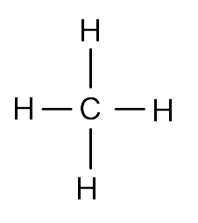
  - Tetrahedral
  - Methane is more ideal because it experience less London dispersion forces (less massive than ammonia) and it is non-polar so it does not experience dipole-dipole forces.
- Justifications
  - Disagree, ionic solids do not conduct
  - Disagree, I2 does have a higher MP but it is due to stronger LDF’s (an intermolecular force)
  - Agree, wax is a covalent molecular solid
  - Disagree, it is ionic intramolecular forces that are weakening
  - Agree, both metallic but sodium’s larger size gives it weaker Coulombic attractions between metal ions.
  - Disagree, liquids densities approximate those of the solid.
  - True, the Coulombic attractions between liquids and gases permit the flow of molecules unlike in solids.
  - Disagree, in most covalent molecular solids (excluding noble gas atoms), there are covalent intramolecular forces within each molecule.
- Potassium chlorate
  - 2KClO3 2KCl + 3O2

    - 600.8 torr
    - 23.0 L
    - 0.0178 moles
    - 1.33 x slower
- Gases
  - Oxygen gas is denser due to higher mass, same volumes
  - Same, same temperature
  - Same, same number of moles, volume and temperature = same pressure
  - F₂ would be 1.08 x slower on average due to higher molecular weight
  - F₂ gas due to smaller size of molecule.
- Toxic gas
  - 130.3 g/mol
  - C₂Cl₃H
  - London dispersion forces and dipole-dipole forces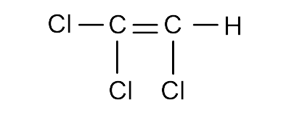
  - 44.9 g/L

