**Similar Triangles & Trigonometry Chapter Problems**

**Problem Solving with Similar Triangles**

**Classwork**

1. A football goal post casts a shadow 120 inches long. You are 5 feet 6 inches tall and cast a shadow 16.5 inches long. Find the height of the goal post in feet. Round your answer to the nearest whole number.
2. Your school building casts a shadow 25 feet long. You are 6 feet tall and cast a shadow 18 inches long. Find the height of the school building in feet

Round your answer to the nearest whole number.

1. A basketball hoop in your backyard casts a shadow 109 inches long. You are 5 feet 8 inches tall and cast a shadow 62 inches long. Find the height of the basketball hoop in inches. Round your answer to the nearest whole number.
2. 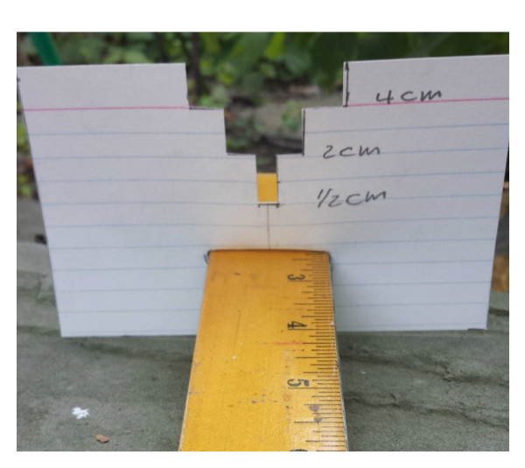The Palace of Westminster in London, England has a clock tower, nicknamed Big Ben that is 96 meters high. Using your similar triangle measuring device, the height of Big Ben fills the 2 cm slot when the card is 16 cm from your eye and turned sideways (shown in the figure below). How far are you from the tower? Round your answer to the nearest whole number.
3. You move to another location and Big Ben (96 m tall) fills the 4 cm slot when the card is 30 cm from your eye. How far are you from Big Ben now? Round your answer to the nearest whole number.
4. Using your similar triangle measuring device, the height of the pine tree fills the 4 cm slot when the card is 8 cm from your eye and turned sideways (shown in the figure above). If you are 20 m from the tree, how tall is it? Round your answer to the nearest whole number.

**Problem Solving with Similar Triangles**

**Homework**

1. 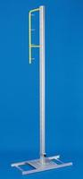A pole vault standard (pictured to the right) casts a shadow 66 inches long. You are 6 feet tall and cast a shadow 40 inches long. Find the height of the pole vault standard in inches. Round your answer to the nearest tenth.
2. Your home casts a shadow 32 feet long. You are 5 feet tall and cast a shadow 42 inches long. Find the height of your home to the nearest tenth.
3. A yardstick casts a shadow 1 ft long. A nearby tree casts a 16 ft shadow. How tall is the tree? Round your answer to the nearest tenth.
4. The height of the Statue of Liberty is 93 meters. Using your similar triangle measuring device (see figure next to #4 & 5), the height of the statue fills the 2 cm slot when the card is 10 cm from your eye and turned sideways. How far are you from the Statue of Liberty?
5. You move to another location and the Statue of Liberty (93 m tall) fills the 4 cm slot when the card is 25 cm from your eye. How far are you from the statue now? Round your answer to the nearest hundredth.
6. Using your similar triangle measuring device, the height of a tall oak tree fills the 2 cm slot when the card is 5 cm from your eye and turned sideways (see figure next to #4 & 5). If you are 150 m from the tree, how tall is it? Round your answer to the nearest whole number.

**Similar Triangles & Trigonometry**

**Classwork**

1. You are standing 50m away from the base of a building. You measure the angle of elevation formed with the ground to be 55°. What is the height of the building?
2. You are standing 63m away from the base of a building. You measure the angle of elevation formed with the ground to be 42°. What is the height of the building?
3. Determine the distance between the flagpole and the school building if the school building is 55m tall and the angle of depression from the top of the school building to the base of the flagpole is 57°.
4. You are at the top of a lighthouse that is 550 ft tall. You look down towards the ocean and see a dolphin. The angle of depression is 58°. How far is the dolphin from the shore?

**Similar Triangles & Trigonometry**

**Homework**

1. You are standing 70m away from the base of a building. You measure the angle of elevation formed with the ground to be 65°. What is the height of the building?
2. You are standing 74m away from the base of a building. You measure the angle of elevation formed with the ground to be 54°. What is the height of the building?
3. Determine the distance between city hall and the library if city hall is 54 feet tall and the angle of depression from the top of city hall to the base of the library is 49°.
4. You are on the deck of a ship that is 450 m above the water. You look down towards the ocean and see a seal. The angle of depression is 42°. How far is the seal from the ship?

**Trigonometric Ratios**

**Classwork**

Refer to the triangle below to answer questions 23-24.

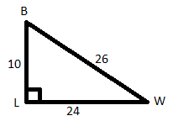

23. side opposite W has length_______; side adjacent W has length _______;

side opposite B has length _______; side adjacent B has length _______;

hypotenuse length is _______.

24. sinW = ______ cosW = ______ tanW = _______.

sinB = ______ cosB = ______ tanB = _______.

Evaluate. Round to the nearest ten-thousandth.

25. sin90°

26. cos52°

27. tan25°

28. tan88°

29. Find the length of . Round to the nearest hundredth.



30. Find the length of . Round to the nearest hundredth.



31. Find the length of . Round to the nearest hundredth.



PARCC-type Questions:

32. If sin30° = .5, then cos60° = ______________. Why?

If cos25° = .9063, then sin65° =_____________. Why?

PARCC-type Questions:

33. Angela flies a kite at a 60° angle of elevation. The kite’s string is 275 feet. Angela’s arm is 4.5 feet off the ground. How high is the kite off the ground? (Round to the nearest hundredth)

34. An airplane flies 6 miles above the ground at an angle of depression of 25°approaching a runway. What is the horizontal distance between the plane and the runway? (Round to the nearest hundredth)

35. You are looking at the top of a tree. The angle of elevation is 78°. The distance from the top of the tree to your position is 125 feet. If you are 5.25 feet tall, how far are you from the base of the tree? (Round to the nearest hundredth)

36. You are on the deck of a cruise ship that is 375 m above the water. You look down towards the ocean and see two orca whales (a.k.a. killer whales). The angle of depression from the ship to the whales is 52° & 53°, respectively.

a) How far is the first orca whale from the ship?

b) How far is the second orca whale from the ship?

c) What is the distance between the 2 orca whales?

d) If the cruise ship stops at one of its destinations & the orcas continue to travel toward the ship at a rate of 10 meters per second, how long will it take them to get to the ship?

**Trigonometric Ratios**

**Homework**

Refer to the triangle below to answer questions 37-38.

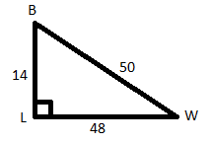

37. side opposite W has length_______; side adjacent W has length _______;

side opposite B has length _______; side adjacent B has length _______;

hypotenuse length is _______.

38. sinW = ______ cosW = ______ tanW = _______.

sinB = ______ cosB = ______ tanB = _______.

Evaluate. Round the nearest ten-thousandth.

39. sin45°

40. tan 77°

41. cos69°

42. tan33°

43. Find the length of $\overline{RF}$. Round to the nearest hundredth.



44. Find the length of . Round to the nearest hundredth.



45. Find the length of . Round to the nearest hundredth.



PARCC-type Questions:

46. If sin60° = .8660, then cos30° = ______________. Why?

If cos65° = .4226, then sin25° =_____________. Why?

PARCC-type Questions:

47. An airplane is 20 miles from the start of the runway. The angle of depression the airplane must use to land is 40°. How high is the airplane above the ground? (Round to the nearest hundredth)

48. You are standing on a mountain that is 6842 feet high. Looking down at your campsite creates an angle of depression of 38°. If you are 5.6 feet tall, how far is the base of the mountain from the campsite? (Round to the nearest hundredth)

49. You are looking at the top of a tree. The angle of elevation is 66°. The distance from the top of the tree to your position is 108 feet. If you are 5.75 feet tall, how tall is the tree? (Round to the nearest hundredth)

50. An archaeological team is excavating artifacts from a sunken merchant vessel on the ocean floor. To help with the exploration, the team uses a robotic probe. The probe travels approximately 4,800 meters at an angle of depression of 69.3° from the team’s ship on the ocean surface down to the sunken vessel on the ocean floor. The figure shows a representation of the team’s ship and the probe.

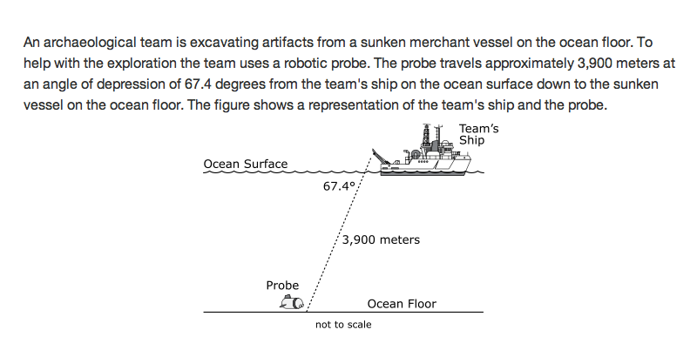

1. When the probe reaches the ocean floor, how far will it be below the ocean surface?
2. When the probe reaches the ocean floor, what will be the horizontal distance between the ship and the probe?

69.3o

4,800 meters

c) If the probe travels horizontally at a speed of 5 meters per second, how long will it take for the probe to be underneath the ship?

**Inverse Trigonometric Ratios**

**Classwork**

Find the measurement of each angle. Round your answer to the nearest hundredth.

51. sin-1 0.7450

52. cos-1 0.6410

53. tan-1 3.6

54. cos-1 0.5678

55. 56.

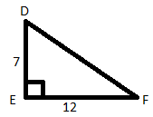 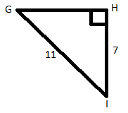

mD = ______ mF = ______ mG = ______ mI = ______

57. 58.

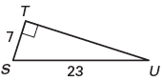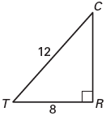

mC = ______ mT = ______ mS = ______ mU = ______

PARCC-type Questions:

59. You lean a 22 foot ladder against the wall. If the base of the ladder is 5 feet from the wall, then what is the measurement of the angle of elevation formed by the base of the ladder and the floor?

60. A soccer player is 30 feet from the goal line. He shoots the ball directly at the goal. The goal is 8 feet high. What is the maximum angle of elevation at which the player can shoot the ball and still score a goal?

61. You are at the top of a lighthouse that is 400 ft tall. You look down towards the ocean and see a whale located 700 ft from the shore. What is the angle of depression from your position?

**Inverse Trigonometric Ratios**

**Homework**

Find the measurement of each angle. Round your answer to the nearest hundredth.

62. tan-1 1.45

63. cos-1 0.3670

64. tan-1 4.8

65. sin-1 0.5678

66. 67.

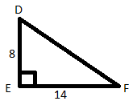 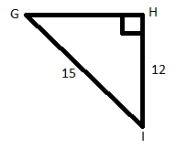

mD = ______ mF = ______ mG = ______ mI = ______

68. 69.

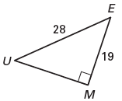 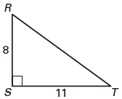

mU = ______ mE = ______ mR = ______ mT = ______

PARCC-type Questions:

70. You lean a 30 foot ladder against the wall. If the base of the ladder is 10 feet from the wall, then what is the measurement of the angle of elevation formed by the base of the ladder and the floor?

71. A soccer player is shooting a penalty kick, which is 12 feet from the goal line. He shoots the ball directly at the goal. The goal is 8 feet high. What is the maximum angle of elevation at which the player can shoot the ball and still score a goal?

72. You are at the top of a lighthouse that is 425 ft tall. You look down towards the ocean and see a boat located 750 ft from the shore. What is the angle of depression from your position?

73. An airplane flies 6 miles above the ground. The distance from the start of the runway to the airplane is 15 miles. What is the angle of depression the airplane must use to land? (Round to the nearest hundredth.)

**Review of Pythagorean Theorem**

**Classwork**

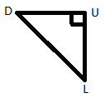

74. In the triangle above, the hypotenuse is side ______, the legs are sides _____ and

______.

Refer the diagram below to answer questions 75-80. Write the answer in simplest radical form.

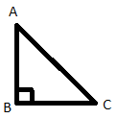

75. If AB = 9 and BC = 12, then AC = _________.

76. If AB = 11 and AC = 61, then BC = _________.

77. If BC = 45 and AC = 53, then AB = __________.

78. If AC = 9 and AB = 3, then BC = _________.

79. If BC = 14 and AC = , then AB = __________.

80. If AB = and BC = , then AC = _________.

81. Find the perimeter and area of the rectangle.

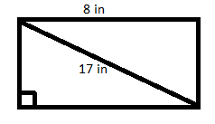

**Review of Pythagorean Theorem**

**Homework**

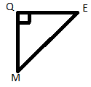

82. In the triangle above the hypotenuse is side ______, the legs are sides _____ and

______.

Refer the diagram below to answer questions 83–88. Write the answer in simplest radical form.

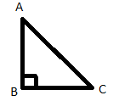

83. If AB = 33 and BC = 56, then AC = _________.

84. If AB = 12 and AC = 37, then BC = _________.

85. If BC = 80 and AC = 89, then AB = __________.

86. If AC = 14 and AB = , then BC = _________.

87. If BC = 9 and AC = 16, then AB = __________.

88. If AB = and BC = , then AC = _________.

89. Find the perimeter and area of the triangle.



**The Converse of the Pythagorean Theorem**

**Classwork**

Classify the sides as lengths of an acute, right, obtuse, or not a triangle.

90. 8, 11, 5

91. 20, 29, 21

92. 6, 2,

93. 9, ,

**The Converse of the Pythagorean Theorem**

**Homework**

Classify the sides as lengths of an acute, right, obtuse, or not a triangle.

94. 19, 7, 15

95. 9, 4, 3

96. 14, 14,

97. , ,

**Special Right Triangles**

**Classwork**

98. The length of each leg of an isosceles right triangle is 13 cm. What is the length of the hypotenuse?

99. The length of the hypotenuse of a 45°-45°-90° triangle is 16 cm. What is the length of each leg?

100. The length of the shorter leg of a 30°-60°-90° triangle is 5 cm. What is the length of the longer leg? What is the length of the hypotenuse?

101. The length of the longer leg of a 30°-60°-90° triangle is 12 cm. What is the length of the hypotenuse? What is the length of the shorter leg?

102. The length of the hypotenuse of a 30°-60°-90° triangle is 12 cm. What is the length of the longer leg? What is the length of the shorter leg?

Find the lengths of the missing sides.

103. 104.

 

105. 106.

 

107.



108. Find the area of the triangle. Round to the nearest hundredth.

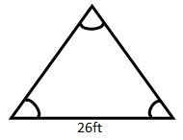

109. A skateboarder constructs a ramp using plywood. The height of the ramp is 4 feet. If the ramp falls at a 60° angle, what is the length of the plywood?

**Special Right Triangles**

**Homework**

110. The length of each leg of an isosceles right triangle is 9 cm. What is the length of the hypotenuse?

111. The length of the hypotenuse of a 45°-45°-90° triangle is 10 cm. What is the length of each leg?

112. The length of the shorter leg of a 30°-60°-90° triangle is 13 cm. What is the length of the longer leg? What is the length of the hypotenuse?

113. The length of the longer leg of a 30°-60°-90° triangle is 21 cm. What is the length of the hypotenuse? What is the length of the shorter leg?

114. The length of the hypotenuse of a 30°-60°-90° triangle is 21 cm. What is the length of the longer leg? What is the length of the shorter leg?

Find the lengths of the missing sides.

115. 116.

 

117. 118.

 

119.



120. Find the area of the triangle. Round to the nearest hundredth.

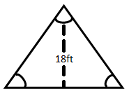

121. A skateboarder constructs a ramp using plywood. The length of the plywood is 7 feet long and falls at a 40° angle. What is the height of the ramp?

***Similar Triangles & Trigonometry Unit Review***

**Multiple Choice** **-** Choose the correct answer for each question. No partial credit will be given.

1. Find the length of the missing side of the triangle. Write the answer in simplest radical form.

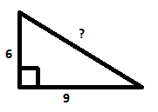

a. 117 b. c. d.

2. Find the length of the missing side of the triangle. Write the answer in simplest radical form.

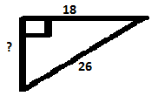

a. $4\sqrt{22}$ b. $16\sqrt{22}$ c. 18.76 d.

3. Tell whether the lengths $7\sqrt{2}$, $3\sqrt{7}$, and 5 form the sides of an acute, right, obtuse, or

not a triangle.

a. acute b. right c. obtuse d. not a triangle

4. In the triangle below, what is the side opposite to J.

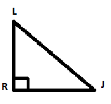

a. b. c. d.

5. What is the tan K?

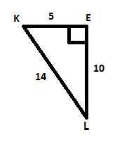

a. 2 b. c. d.

6. Find the m $∠$ V. Round the answer to the nearest hundredth.

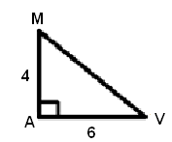

a. 33.69°b. 56.31°c. 41.81°d. 48.19°

7. Find the length of $\overline{DT}$. Round the answer to the nearest hundredth.



a. 8.31 b. 6.64 c. 6.26 d. 3.99

8. Find the m $∠$ D. Round the answer to the nearest hundredth.

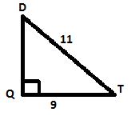

a. 50.71° b. 39.29° c. 35.10° d. 54.90°

9. Find the length of . Round the answer to the nearest hundredth.



a. 3.01 b. 3.77 c. 6.64 d. 3.99

10. In the figure, sin 47 = 15/x, which of the following equations is also true?



a. sin 43 = x/15 b. cos 43 = 15/x c. cos 47 = 15/x d. tan 47 = x/15

11. Find the value of x. Write the answer in simplest radical form.



a. b. 7.5 c. d.

12. Find the value of x. Write the answer in simplest radical form.

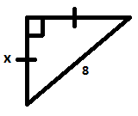

a. b. c. d. 4

13. Find the value of x. Write the answer in simplest radical form.

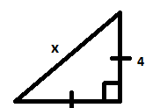

a. $2\sqrt{2}$ b. $4\sqrt{2}$ c. $\frac{4\sqrt{2}}{2}$ d. 2

**Short Constructed Response -** Write the answer for each question. No partial credit will be given.

14. Tell whether the lengths $7\sqrt{3}$, $3\sqrt{11}$, and $4\sqrt{5}$ form the sides of an acute, right, obtuse or not a triangle.

15. Find the perimeter & area of the triangle. Round your answers to the nearest hundredth.

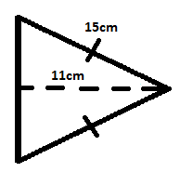

16. If cos18° = .9511, then what is the sin72°? Explain the relationship between these two values and why the relationship occurs.

17. Michael is flying a kite at an angle of 45°. The kite's string is 202 feet long and Amy arm is 4 feet off the ground. How high is the kite off the ground?

18. You are looking at the top of a tree. The angle of elevation from your line of site to the top of the tree is 57°. You are 26 feet from the base of the tree and your eyes are 5’ 9” above the ground. How tall is the tree? Round to the nearest hundredth.

19. An ice hockey player is shooting a penalty shot. He shoots the puck directly at the goal when he is 21 feet away. The goal is 4 feet high. What is the maximum angle of elevation at which the player can shoot the puck and still score a goal? Round your answer to the nearest hundredth.

20. Your school casts a shadow 40 feet long. At the same time a person 6 feet casts a shadow 3.5 feet long. Sketch and label a diagram. Find the height of your school. Round your answer to the nearest hundredth.



21. Using your similar triangle measuring device (shown to the right), the height of a very tall oak tree fills the 0.5 cm slot when the card is 9 cm from your eye and turned sideways. If you are 1,350 m away from the tree, how tall is it? Round your answer to the nearest whole number.

**Extended Constructed Response -** Solve the problem, showing all work. Partial credit may be given.

22. You are on the deck of a cruise ship that is 425 m above the water. You look down towards the ocean and see dolphins. The angle of depression from your line of sight to the dolphins is 42° & 44°, respectively.

a) How far is the first dolphin from the ship?

b) How far is the second dolphin from the ship?

c) What is the distance between the 2 dolphins?

d) If the cruise ship stops at one of its destinations & the dolphins continue to travel toward the ship at a rate of 11 meters per second, how long will it take them to get to the ship?

23. An airplane flies 10 miles above the ground. The distance from the start of the runway to the airplane is 35 miles.

a) If the airplane starts its decent, what is the angle of depression the airplane must use to land? Round to the nearest hundredth.

b) If the airplane travels horizontally for an additional 10 miles, what is the angle of depression the airplane must use to land? Round to the nearest hundredth.

c) If the airplane flew horizontally for the additional 10 miles in part b) and descended at an angle of depression of 23°, would they land safely on the runway? Explain your answer.

**Answer Key**

1. 40 feet
2. 100 feet
3. 120 inches
4. 768 meters
5. 720 meters
6. 10 meters
7. 118.8 inches = 9.9 ft
8. 45.7 feet
9. 48 ft
10. 465 meters
11. 581.25 meters
12. 60 meters
13. 71.4 meters
14. 56.7 meters
15. 35.7 meters
16. 343.7 feet
17. 150.1 meters
18. 101.9 meters
19. 46.9 feet
20. 499.8 meters
21. 10,24,24,10,26
22. 5/13,12/13,5/12,12/13,5/13,12/5
23. 1.0000
24. 0.6157
25. 0.4663
26. 28.6363
27. 8.07
28. 14.83
29. 16.26
30. 0.5, 0.9063 because the side adjacent to one angle is opposite its complementary angle
31. 242.66 ft
32. 12.87 miles
33. 25.99ft
34. a) 282.58 m   
    b) 292.98 m  
    c) 10.40 m  
    d) 28.26 sec & 29.30 sec respectively
35. 14, 48, 48, 14, 50
36. 7/25, 24/25, 7/24, 24/25, 7/25, 24/7
37. 0.7072
38. 4.3315
39. 0.3584
40. 0.6494
41. 22.28
42. 23.66
43. 2.20
44. 0.8660, 0.4226 because the side adjacent to one angle is opposite its complementary angle
45. 12.86 miles
46. 8764.37ft
47. 104.41ft
48. a) 4,490.13 m  
    b) 1,696.68 m  
    c) 339.34 seconds = 5.66 min.
49. 48.16°
50. 50.13°
51. 74.48°
52. 55.40°
53. 59.74° & 30.26°
54. 39.52° & 50.48°
55. 41.81° & 48.19°
56. 72.28° & 17.72°
57. 76.86°
58. 14.93°
59. 29.74°
60. 55.41°
61. 68.47°
62. 78.23°
63. 34.60°
64. 60.26° & 29.74°
65. 53.13° & 36.87°
66. 42.73° & 47.27°
67. 53.97° & 36.03°
68. 70.53°
69. 33.69°
70. 29.54°
71. 23.58°
72. hypotenuse – DL  
    sides - DU and UL
73. 15
74. 60
75. 28
$6\sqrt{2}$

$6\sqrt{7}$

$8\sqrt{3}$

76. Perimeter = 46in  
    Area = 120in2
77. hypotenuse – ME  
    sides - MQ and QE
78. 65
79. 35
80. 39
$\sqrt{146}$

$5\sqrt{7}$

$2\sqrt{86}$

81. Perimeter = (62+ $4\sqrt{30})$ cm ≈ 83.9cm  
    Area = cm2 ≈ 317.7 cm2
82. obtuse
83. right
84. Not a Triangle
85. acute
86. obtuse
87. Not a Triangle
88. right
89. acute
90. 13 $\sqrt{2}$ cm
91. $8\sqrt{2}$ cm
92. LL $=5\sqrt{3}$ cm H = 8 $\sqrt{3}cm$
93. $H= 8\sqrt{3}$ cm SL = 4 $\sqrt{3}$
94. LL = $6\sqrt{3}$, SL = $6$
95. x = $18\sqrt{3}cm$, y = $36$ cm
96. x = $9cm$, y = $9\sqrt{3}$ cm
97. $x=6\sqrt{3}cm$, y = 12 $\sqrt{3}cm$
98. x = 6cm, y = 6 $\sqrt{2}cm$
99. x = 3 $\sqrt{2}$, y = 3 $\sqrt{2}$
100. 292.72ft2
101. 8ft
102. 9 cm
103. 5 $\sqrt{2}$ cm
104. H = 26cm, LL = 13 $\sqrt{3}$ cm
105. SL = 7 $\sqrt{3}$ cm, H = 14 $\sqrt{3}$ cm
106. LL = (21 $\sqrt{3})$/2cm, SL = 10.5cm
107. x = 24 $\sqrt{3} cm$, y = 48
108. x = 12 $\sqrt{3}$ cm, y = 12cm
109. x = 16 $\sqrt{3} cm,$ y = 8 $\sqrt{3} cm$
110. x = 10, y = 10 $\sqrt{2}$ cm
111. x = $5\sqrt{2}$ cm, y = $5\sqrt{2}$ cm
112. 187.06 ft2
113. 6.58ft

**Similar Triangles & Trig Unit Review**

1. D  
2. A  
3. C  
4. D  
5. A  
6. A  
7. C  
8. D  
9. B

10. B

11. C  
12. A  
13. B

14. acute

15. P = 50.40 units & A = 112.18 units2

16. sin72o = 0.9511; These values are the same because the cosine of an angle is equivalent to the sine of its complementary angle.

17. 146.83 feet

18. 40.03 + 5.75 = 45.78 feet

19. angle must be less than 10.78°

20. 68.57 feet  
21. 75 meters  
22. A) 440.10 meters

B) 472.01 meters

C) 31.91 meters

D) 40.01 seconds & 42.91 seconds  
23. A) 15.95°

B) 21.80°

C) No, if the angle of depression of the plane is 23°, then the plane would not make it to the runway