ANALYZING FUNCTIONS USING DERIVATIVES UNIT PROBLEM SETS

PROBLEM SET #1 – Extreme Values – Graphically ***Calculators Not Allowed***

Use the graph below to answer each question.

Determine whether each of the following is a local or absolute minimum/maximum. If none of them occur, write “none”.

- Point a

- Point b

- Point c

- Point d

- Point e

- Point f

- Point g

- Determine the interval(s) where the function is increasing.

- Determine the interval(s) where the function is decreasing.

- Determine the critical values of the graph.

Use the graph below to answer each question.

Determine whether each of the following is a local or absolute minimum or maximum. If none of them occur, write “none”.

- Point g

- Point h

- Point i

- Point j

- Point k

- Point m

- Point n

- Point p

- Point q

- Determine the interval(s) where the function is increasing.

- Determine the interval(s) where the function is decreasing.

- Determine the critical values of the graph.
PROBLEM SET #2 – 1st Derivative Test ***Calculators Not Allowed***
Can use calculator on #8, 9 & 12

Determine the critical values of each function.

- $f\left(x\right)=x^{3}+2x^{2}-15x-20$

- $f\left(x\right)=\frac{8}{x^{2}-2x+5}$

- $f\left(x\right)=\sqrt[5]{x^{2}}$

- $f\left(x\right)=\frac{1}{5}x^{5}-\frac{26}{3}x^{3}+25x$

Identify the intervals where the function is increasing & decreasing. Then, determine the local extrema of each function.

- $f\left(x\right)=x^{3}+3x^{2}-24x+12$

- $f\left(x\right)=\frac{4}{x^{2}+4x+5}$

- $f\left(x\right)=\sqrt[5]{x^{4}}$

- $f\left(x\right)=\frac{1}{5}x^{5}-\frac{13}{3}x^{3}+36x$

Identify the intervals where the function is increasing & decreasing. Then, determine the local extrema of each function. Lastly, determine the absolute extrema of each function.

- $f\left(x\right)=x^{4}+\frac{4}{3}x^{3}-12x^{2}, [-4, 3]$

- $f\left(x\right)=\frac{6}{x^{2}+2x+3}, [-4, 2]$

- $f\left(x\right)=\frac{4sinx}{x}, [-π, π]$

- $f\left(x\right)=\frac{1}{4}x^{4}+\frac{1}{3}x^{3}-8x^{2}-16x, [-4, 4]$

PROBLEM SET #3 – Concavity & 2nd Derivative Test ***Calculators Not Allowed***

Determine the critical values of concavity for each function.

- $f\left(x\right)=x^{3}+3x^{2}-6x-18$

- $f\left(x\right)=\frac{5}{x^{2}-2x+8}$

- $f\left(x\right)=\sqrt[7]{x^{3}}$

- $f\left(x\right)=x^{5}-20x^{3}+55x$

Identify the intervals of concavity and the points of inflection.

- $f\left(x\right)=x^{3}+6x^{2}-4x-24$

- $f\left(x\right)=\frac{x}{e^{x}}$

- $f\left(x\right)=\sqrt[7]{x^{5}}$

- $f\left(x\right)=\frac{1}{2}x^{4}-4x^{3}+9x^{2}$

Using the 2nd Derivative test, determine the local extrema of each function.

- $f\left(x\right)=x^{4}-10x^{2}+9$

- $f\left(x\right)=\frac{4ex}{e^{x}}$; Note: e in the numerator
means $e^{1}$

- $f\left(x\right)=cosx, [-2π, 2π]$

- $f\left(x\right)=\frac{1}{3}x^{3}+\frac{3}{2}x^{2}-18x+26$

PROBLEM SET #4 – Connecting Graphs of f, f’, & f’’ ***Calculators Not Allowed***

The graph below is the derivative of a function, f, whose domain is the set of all real numbers and is continuous everywhere. Use the graph to answer the questions.

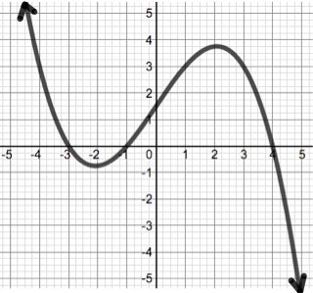
- Determine the intervals where f is increasing.

- Determine the intervals where f is decreasing.

- Determine the x values for the relative extrema for f.

- Determine the intervals where f is concave up.

- Determine the intervals where f is concave down.

- Determine the x-values of the point(s) of inflection.

The graph below is the derivative of a function, g, whose domain is the set of all real numbers and is continuous everywhere. Use the graph to answer the questions.

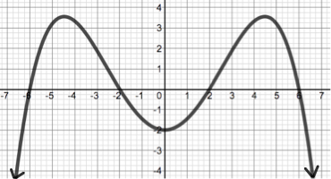
- Determine the intervals where g is
increasing.

- Determine the intervals where g is
decreasing.

- Determine the x values for the relative
extrema for g.

- Determine the intervals where g is concave up.

- Determine the intervals where g is concave down.

- Determine the x-values for the point(s) of inflection.
The graph below is the second derivative of a function, h, whose domain is the set of all real numbers and is continuous everywhere. Use the graph to answer the questions.

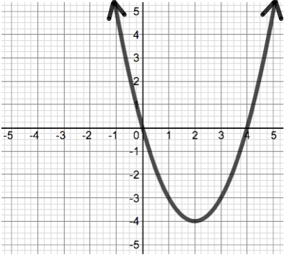
- Determine the intervals where h is concave up.

- Determine the intervals where h is concave
down.

- Determine the x-values for the point(s) of inflection.

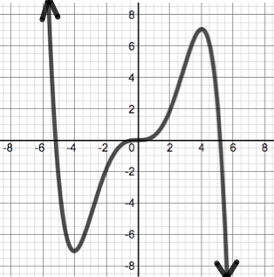
The graph below is a function, j, whose domain is the set of all real numbers and is continuous everywhere. Use the graph to answer the questions.

- Determine the intervals where j is increasing.

- Determine the intervals where j is decreasing.

- Determine the relative extrema for j.

- Determine the intervals where j is concave up.

- Determine the intervals where j is concave down.

- Determine the x-values for points of inflection.

PROBLEM SET #5 – Curve Sketching ***Calculators Not Allowed***

Each graph provided is the graph of the derivative function, f’(x). The domain for each original function f(x) is the set of all real numbers and is continuous everywhere. Use the provided information to create a sketch of each original function.

- Zeros: x = -2, x = 0, x = 5
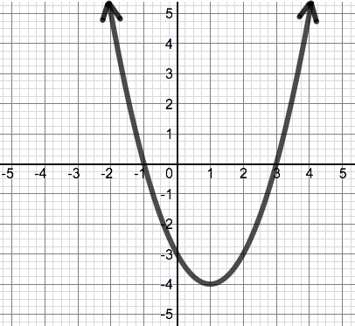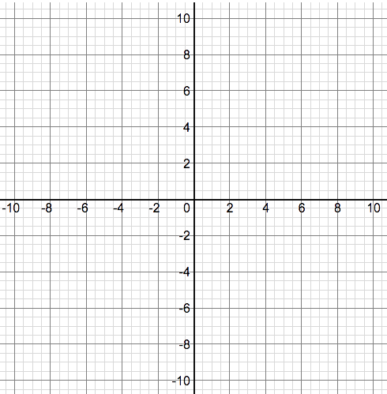
- Zeros: x = -4, x = 1 & x = 6
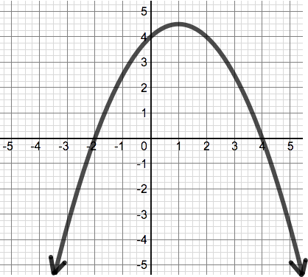
- Zeros: x = -1 & x = 7
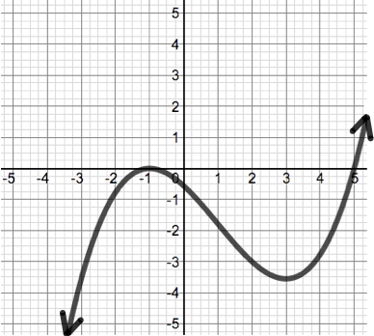
- Zeros: x = -7.25, x = -4, x = 0, x = 4 & x = 7.25
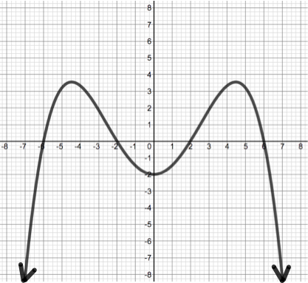

Each function, f, is continuous on the interval provided with the given qualities. The functions f’ and f’’ have their properties given in a table. Sketch a graph that satisfies the given properties of f.

- Interval: $(-∞,∞)$ Zeros: x = -5, x = 0, x = 3.5
x | $$-∞<x<-3$$ | x = -3 | -3 < x < -0.5 | x = -0.5 | -0.5 < x < 2 | x = 2 | $$2<x<∞$$
f'(x) | Positive | 0 | Negative | Negative | Negative | 0 | Positive
f'’(x) | Negative | Negative | Negative | 0 | Positive | Positive | Positive

Graph for #5 Graph for #6

- Interval: $(-∞,∞)$ Zeros: x = -3, x = 0, x = 7
x | $$-∞<x<-2$$ | x = -2 | -2 < x < -1 | x = -1 | -1 < x < 0 | x = 0
f'(x) | f’(x) < 0 | f’(x) = 0 | f’(x) > 0 | f’(x) > 0 | f’(x) > 0 | f’(x) = 0
f'’(x) | f'’(x) > 0 | f'’(x) > 0 | f'’(x) > 0 | f'’(x) = 0 | f'’(x) < 0 | f'’(x) < 0
x | 0 < x < 2.5 | x = 2.5 | 2.5 < x < 5 | x = 5 | $$5<x<∞$$
f'(x) | f’(x) < 0 | f’(x) < 0 | f’(x) < 0 | f’(x) = 0 | f’(x) > 0
f'’(x) | f'’(x) < 0 | f'’(x) = 0 | f'’(x) > 0 | f'’(x) > 0 | f'’(x) > 0

- Interval: [-5, 6] f(-5) = -3.5 and f(6) = -1
x | $$-5<x<-3$$ | x = -3 | -3 < x < -2 | x = -2 | -2 < x < -1 | x = -1
f'(x) | Positive | 0 | Negative | Negative | Negative | 0
f'’(x) | Negative | Negative | Negative | 0 | Positive | Positive
x | -1 < x < 1 | x = 1 | 1 < x < 4 | x = 4 | $$4<x<5$$
f'(x) | Positive | DNE | Negative | 0 | Positive
f'’(x) | Positive | DNE | Positive | Positive | Positive

Graph for #7 Graph for #8
- Interval: [-6, 2] f(-6) = -2 and f(2) = -2
x | $$-6<x<-4$$ | x = -4 | -4 < x < -2 | x = -2 | -2 < x < 0 | x = 0 | 0 < x < 2
f'(x) | f'(x) > 0 | f'(x) = 0 | f'(x) < 0 | DNE | f'(x) > 0 | f'(x) = 0 | f'(x) < 0
f'’(x) | f'’(x) < 0 | f'’(x) < 0 | f'’(x) < 0 | DNE | f'’(x) < 0 | f'’(x) < 0 | f'’(x) < 0

- The derivative of a certain continuous and differentiable function is given by:
$y^{'}=3x^{2}-12x+9$. Analyze the function and create a sketch of the original if the only zeros are at x = 0, and x = 3.
Graph for #9 Graph for #10
- The derivative of a certain continuous and differentiable function is given by:
$y^{'}=-x^{3}-6x^{2}-9x$. Analyze the function and create a sketch of the original if the only zeros are at x = 1 and x = -4.
PROBLEM SET #6 – Rolle’s Theorem ***Calculators Not Allowed***
Can use calculator on #4, 7 & 9
#1-10: Find the value(s) of c that satisfy Rolle’s Theorem for each function. If it is not possible, write “Not Possible”.

- $f\left(x\right)=x^{2}+5x-6$, [-5, 0]

- $f\left(x\right)=\cos\left(x-\frac{π}{4}\right), \left[\frac{3π}{4},\frac{11π}{4}\right]$

- $f\left(x\right)=x^{3}+{5x}^{2}-x-5, \left[-5, \frac{3}{2}\right]$

- $f\left(x\right)=\frac{1}{3}x^{3}+\frac{5}{2}x^{2}-6x-20$, [-9, 3]

- $f\left(x\right)=\frac{x^{2}-x-20}{x+6}, [-5, 16]$

- $f\left(x\right)=x^{3}+2x^{2}-4x-8$,
[-3, 2]

- $f\left(x\right)=\csc\left(x+\frac{π}{2}\right), \left[-\frac{5π}{4},-\frac{3π}{4}\right]$

- $f\left(x\right)=x^{4}-10x^{2}+9$, [-3, 3]

- $f\left(x\right)={\frac{1}{4}x}^{4}+\frac{2}{3}x^{3}-2x^{2}-8x-5$,
[-4, 4]

- $f\left(x\right)=\frac{{-x}^{2}+7x-10}{x+4}, [-1, 14]$

PROBLEM SET #7 – Mean Value Theorem ***Calculators Not Allowed***

Find the value(s) of c that satisfy the Mean Value Theorem for each function. If it is not possible, write “Not Possible” and explain why.

- $f\left(x\right)=x^{3}$, [-2, 3]

- $f\left(x\right)=\left|5x+3\right|$, [-1, 4]

- $f\left(x\right)=7+ln⁡(x+5)$, [-4, 0]

- $f\left(x\right)=\sqrt{x+4}$, [-4, 6]

- $f\left(x\right)=\cos\left(3x\right), \left[\frac{π}{6},\frac{7π}{6}\right]$

- $f\left(x\right)=x^{3}+2x^{2}-4x-8$,
[-3, 2]

- $f\left(x\right)=\sin\left(x-\frac{π}{2}\right), \left[\frac{3π}{4},\frac{5π}{4}\right]$

- $f\left(x\right)=\sqrt{4-x}$, [0, 5]

- $f\left(x\right)=\frac{x^{2}+3x-40}{x+4}, [0, 5]$

- $f\left(x\right)=e^{2x}$, [0, 2]

PROBLEM SET #8 – Newton’s Method ***Calculators Allowed***

Use Newton’s Method to approximate the root of each function accurate to 6 decimal places.

- $f\left(x\right)=x^{3}+2x^{2}-10x-20$, $x_{1}=-3$

- $f\left(x\right)=e^{x+4}+6x$, $x_{1}=-2$

- $f\left(x\right)=x^{3}+7x^{2}-5x-35$, $x_{1}=2$

- $f\left(x\right)=\frac{\cos{(π-x)}}{x}$, $x_{1}=-5$

- $f\left(x\right)=\ln\left(x-4\right)-x+6$, $x_{1}=7$

- $f\left(x\right)=\frac{1}{5}x^{5}-\frac{26}{3}x^{3}+25x$, $x_{1}=2$

- $f\left(x\right)=\frac{1}{4}x^{4}+\frac{1}{3}x^{3}-8x^{2}-16x$, choose your own $x_{1}$ value

- $f\left(x\right)=\frac{\sin{(0.5π+x)}}{2x}$, choose your own $x_{1}$ value

PROBLEM SET #9 – Optimization ***Calculators Allowed***

Solve each word problem.
- A farmer is creating a rectangular pen for his animals that is adjacent to a barn (Note: no fencing needed for that side). He has 180 feet of fencing to use. What length and width would produce the largest area for the pen? What is the area of the pen?

- A can of soup is being constructed out of aluminum. The volume of the can is 24 cubic inches. What should be the height of the can in order to minimize the amount of aluminum used?

- A farmer is creating 3 congruent rectangular pens that are adjacent to each other with 1,800 feet of fencing. What length and width would produce the largest areas for the pens? What is the area of each pen? What is the total area for all 3 pens?

- A sheet of cardboard is 4 feet by 5 feet will be made into a box by cutting equal squares from each corner & folding up the 4 edges. What will be the dimensions of the box with the largest volume?

- Find the point (x, y) on the graph of $y=\sqrt{x}$ nearest to the point (7, 0).

- Car B is 45 miles directly east of Car A and begins moving west at 75 mph. At the same moment, Car A begins moving south at 65 mph. What will be the minimum distance between the cars and at what time t does the minimum distance occur?

- Assume that c(x) is the cost to create products for a business, and r(x) is the revenue from selling the products, and p(x) is the profit (or revenue – cost). If x represents the number of products created, in thousands, find the production level that will maximize their profit if:
$c\left(x\right)=x^{3}-5x^{2}+25x$ and $r\left(x\right)=10x^{2}$.

- A closed top box is created by cutting out 2 squares and 2 long rectangles from a piece of cardboard and folding the sides as shown in the figure below. If the cardboard is 34 inches by 12 inches, then what is the measurement of the cut that would produce a maximum volume? What is the maximum volume?

Answers:

PROBLEM SET #1
- none
- local max
- none
- none
- absolute & local min
- absolute & local max
- none
- $(a, b)∪(e, f)$
- $(b, e)∪(f, g)$
- b, d, e, and f
- none
- local max
- none
- local & absolute min
- none
- local max
- none
- local min
- absolute max
- $(g, h)∪(j, m)∪(p, q)$
- $(h, j)∪(m, p)$
- h, j, m, p

PROBLEM SET #2
- $x=-3, x=\frac{5}{3}$
- x = 1
- x = 0
- $x=±5, x=±1$
- increasing: $(-∞, -4)∪(2, ∞)$
decreasing: $(-4, 2)$
local min: (2, -16)
local max: (-4, 92)
- increasing: $\left(-∞, -2\right)$
decreasing: $\left(-2, ∞\right)$local max: (-2, 4)
- increasing: $(0,∞)$
decreasing: $(-∞, 0)$
local min: (0, 0)
- increasing: $(-∞, -3)∪(-2, 2)∪(3, ∞)$
decreasing: $(-3, -2)∪(2, 3)$,
local min: $\left(-2, -\frac{656}{15}\right) \& \left(3, \frac{198}{5}\right)$
local max: $\left(2, \frac{656}{15}\right) \& \left(-3, -\frac{198}{5}\right)$
- increasing: $(-3, 0)∪(2, 3)$
decreasing: $(-4, -3)∪(0, 2)$
local min: (2, $-\frac{64}{3}$)
local max: (0,0)
absolute max: (3, 9)
local & absolute min: $\left(-3, -63\right)$
- increasing: $(-4, -1)$
decreasing: $(-1, 2)$
local & absolute max: (-1, 3)
absolute min: $\left(-4,\frac{6}{11}\right)∪\left(2,\frac{6}{11}\right)$
- increasing: $(-π,0)$
decreasing: $(0, π)$
local & absolute max: (0, 4)
- increasing: $(-4, -1)$
decreasing: $(-1, 4)$
local and absolute max: $\left(-1, \frac{95}{12}\right)$
absolute min: $\left(4, -\frac{320}{3}\right)$

PROBLEM SET #3
- $x=-1$
- $x=\frac{3±\sqrt{21}}{3}$
- x = 0
- $x=0, x=±\sqrt{6}$
- concave up: $(-2, ∞)$
concave down: $(-∞, -2)$
inflection point: (-2, 0)
- concave up: $(2,∞)$
concave down: $(-∞, 2)$
inflection point: $\left(2, \frac{2}{e^{2}}\right)$
- concave up: $(-∞, 0)$
concave down: $(0, ∞)$
inflection points: (0, 0)
- concave up: $(-∞, 1)∪(3, ∞)$
concave down: $(1, 3)$
inflection pts: (1, 5.5) & (3, 13.5)
- local minima: $\left(\sqrt{5}, -16\right) \& (-\sqrt{5}, -16)$
local maximum: (0, 9)
- local maximum: (1, 4)
- local minima: $\left(-π, -1\right) \& (π, -1)$
local maxima: $(0, 1)$
- local minima: $\left(3, -\frac{11}{2}\right)$
local maximum: (-6,116)

PROBLEM SET #4
- $(-∞, -3)∪(-1, 4)$
- $(-3,-1)∪(4, ∞)$
- local min: x = -1
local max: x = -3 & x = 4
- $(-2, 2)$
- $(-∞, -2)∪(2, ∞)$
- points of inflection: x = -2 & x = 2
- $(-6, -2)∪(2, 6)$
- $(-∞, -6)∪(-2, 2)∪(6, ∞)$
- local min: x = -6 & x = 2
local max: x = -2 & x = 6
- $(-∞, -4.5)∪(0, 4.5)$
- $(-4.5, 0)∪(4.5, ∞)$
- points of inflection: x = -4.5, x = 0 &
x = 4.5
- $(-∞, 0)∪(4, ∞)$
- (0, 4)
- x = 0 & x = 4
- $(-4, 0)∪(0, 4)$
- $(-∞, -4)∪(4, ∞)$
- local max: (4, 7) & local min: (-4, -7)
- $(-∞, -2.5)∪(0, 2.5)$
- $(-2.5, 0)∪(2.5, ∞)$
- x = -2.5, x = 0 & x = 2.5

PROBLEM SET #5
- increasing: $(-∞, -1)∪(3, ∞)$
decreasing: $(-1, 3)$
local min: x = 3
local max: x = -1
concave up: $\left(1, ∞\right)$
concave down: $\left(-∞, 1\right)$
Inflection points: x = 1
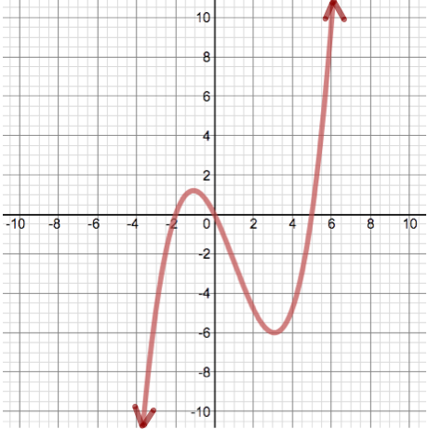
- increasing: $(-2, 4)$
decreasing: $(-∞, -2)∪(4, ∞)$
local min: x = -2
local max: x = 4
concave up: $\left(-∞, 1\right)$
concave down: $\left(1, ∞\right)$
Inflection points: x = 1
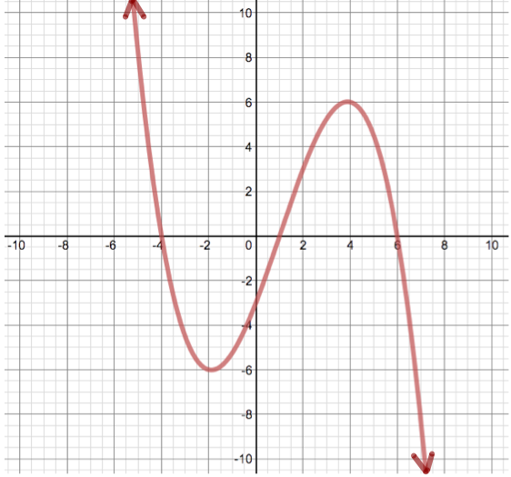
- increasing: $(5, ∞)$
decreasing: $(-∞, -1)∪(-1, 5)$
local min: x = 5
concave up: $\left(-∞, -1\right)∪\left(3, ∞\right)$
concave down: (-1, 3)
Inflection points: x = -1 & x = 3
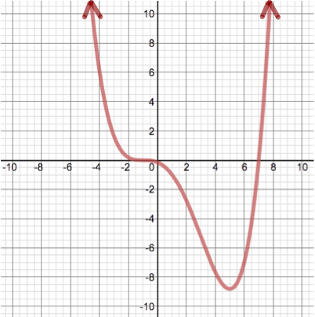
- increasing: $(-6, -2)∪(2, 6)$
decreasing: $(-∞, -6)∪(-2, 2)∪(6, ∞)$
local min: x = -6, x = 2
local max: x = -2, x = 6
concave up: $\left(-∞, -4.5\right)∪\left(0, 4.5\right)$
concave down: $(-4.5, 0)∪(4.5, ∞)$
Inflection points: x = -4.5, x = 0 &
x = 4.5
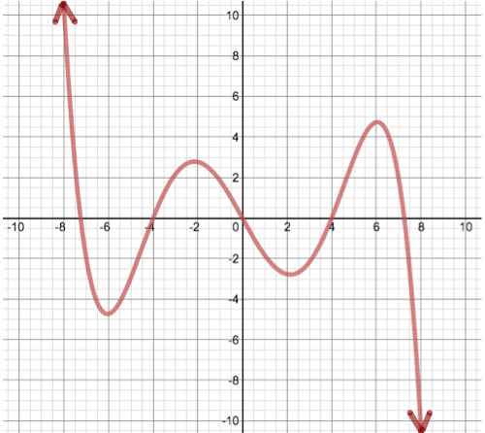

- 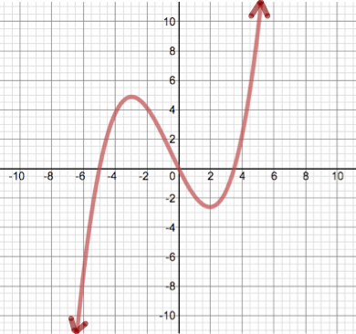
- 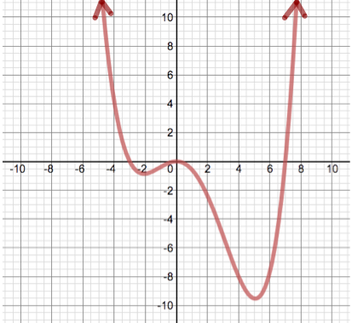
- 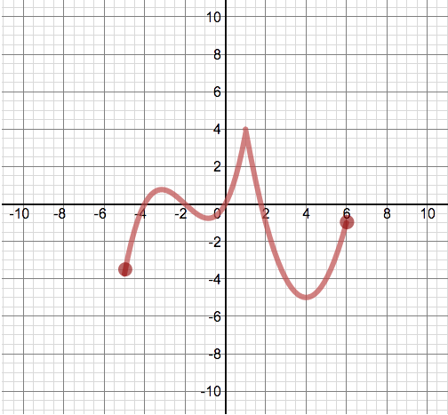
- 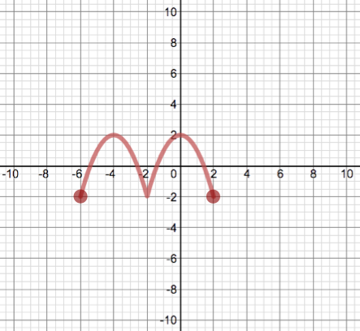
- 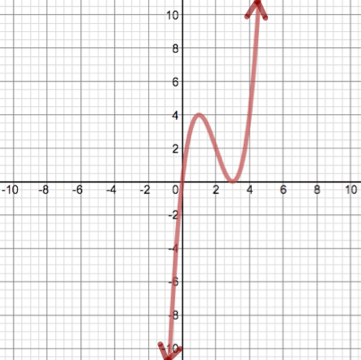
- 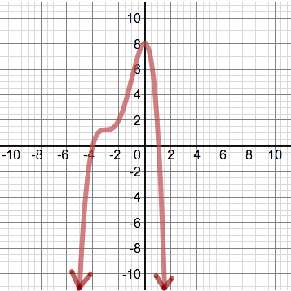

PROBLEM SET #6
- $c=-\frac{5}{2}$
- $c=\frac{5π}{4}, c=\frac{9π}{4}$
- Not Possible
- $c=1, c= -6$
- $c=-6+\sqrt{22}$
- Not Possible
- $c=-π$
- $c=0, c=±\sqrt{5}$
- Not Possible
- $c=-4+3\sqrt{6}$

PROBLEM SET #7
- $c=±\sqrt{\frac{7}{3} } or c=±\frac{\sqrt{21}}{3}$ (if you rationalize the fraction)
- Not possible; not differentiable on the interval due to the corner at x = -0.6
- $c=\frac{4}{ln⁡(5)}-5$
- $c=-\frac{3}{2}$
- $c=\frac{π}{3}, c=\frac{2π}{3}, c=π$
- $c=\frac{-2±\sqrt{19}}{3}$
- $c=π$
- Not possible; function does not exist on entire interval (0, 5)
- c = 2
- $c=\frac{\ln\left(e^{4}-1\right)-ln⁡(4)}{2}$

PROBLEM SET #8
- -3.162277
- -1.685925
- 2.236067
- -4.712388
- 7.146193
- 1.762796
- 5.911401
- 7.853981

PROBLEM SET #9
- $l=90 ft, w=45 ft \& A=4,050{ft}^{2}$
- h = 3.126 in. (Note: r = 1.5631853 in.)
- $l=225 ft, w=150 ft$
Area of 1 pen: $A=33,750 {ft}^{2}$
Total Area: $A=101,250 {ft}^{2}$
- h = 0.736 ft, w = 2.528 ft &
$$l=3.528 ft$$
- x = 6.5 & y = 2.549
- t = 0.342 hours
minimum distance = 29.472 miles
- x = 9.082 thousand products would maximize profit
- size of the cut: x = 2.689 in.
Volume: 254.830 ${in}^{3}$

